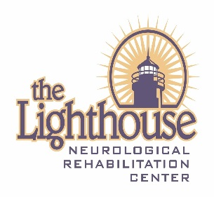
Lighthouse Neurological Rehabilitation Center
2019 Adaptive Sports
Volunteer Information Form

What adaptive sport clinics are you volunteering for?
Adaptive Cycle:
May 28 _____
June 11 _____
June 25 _____
Adaptive Kayak:
July 16 _____
July 30 _____
August 13 _____

Name: __________________________________
Phone: __________________________________
Email: ___________________________________
Address: _________________________________
City: ___________________ State: _________________ Zip: ______________
Date of Birth: ____________________
Emergency Contact: ________________ Relationship: ___________________
Phone: _________________
Do you have any talents or specialties that may assist with either event? If so please list: ____________________________________________________________________________________________________________________________________________

Have you volunteered for the Lighthouse Adaptive Sports Events in the past?
YES _____ NO______

Signature: _________________________________________ Date: ________

