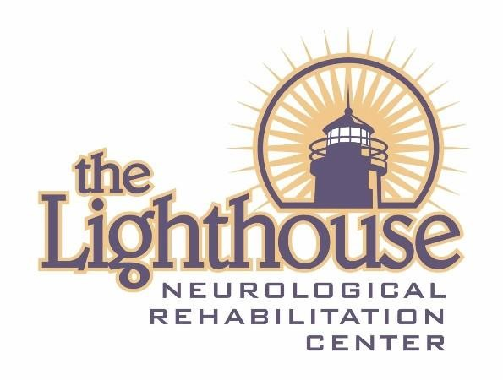

Residential
Scope of Service
2020

The Lighthouse Campuses

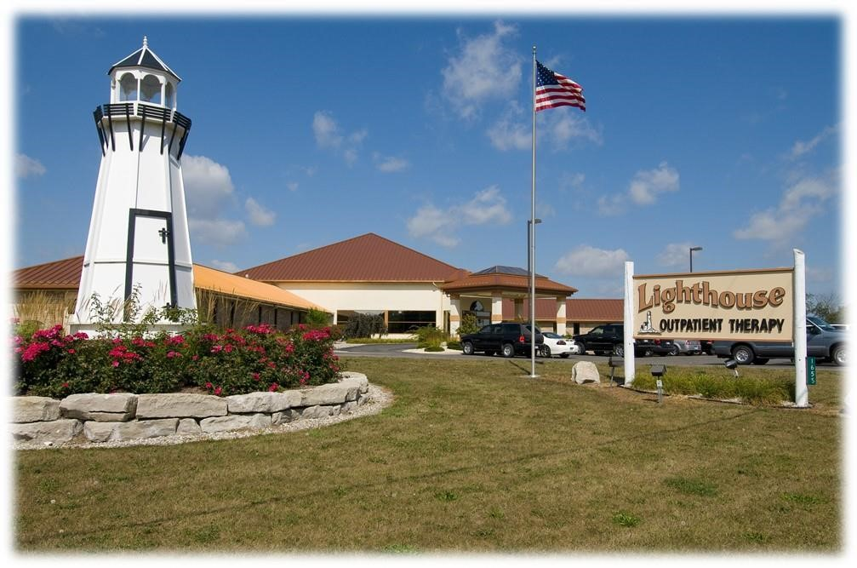

Caro, MI

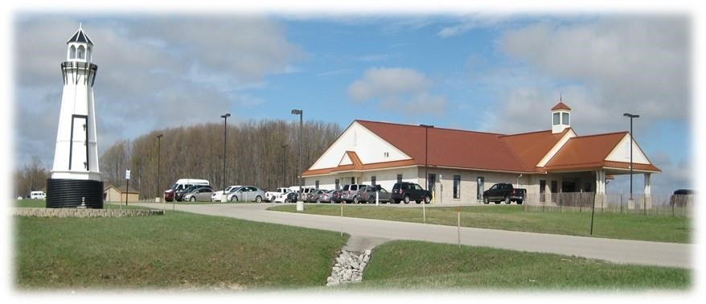
Kingsley, MI

OUR MISSION

Lighthouse provides phenomenal care, treating every resident as we wanted our son to be treated.

OUR CORE VALUES

- Glorify God in all that we do
- Serve every person with excellence
- Do unto others as you would like them to do unto you
- Honesty and integrity in dealing with our families, payors, and employees

OUR TREATMENT PHILOSOPHY

The Lighthouse recognizes each resident is a whole person made up of body, mind, and spirit. Through a comprehensive rehabilitation program by an interdisciplinary team of professionals, The Lighthouse gives assistance to individuals as they strive to achieve their highest level of independence in the least restrictive environment.

Treatment Approach
Multidisciplinary team of professionals
Strength-based program
Supportive environment

Treatment Direction
Maximize physical and psychological functioning
Improve relationships with others
Encourage family involvement
Integrate physical and mental healing
Address spiritual needs according to the individual’s personal preference

Hours of Service
24 hours a day 7 days a week
Services provided in the frequency prescribed by treating physician

Fees and Funding Sources

Service fees are competitive with industry standard.

The Lighthouse participates with a variety of funding sources. Funding sources may include automobile insurance companies, HMOs, self-insured employer plans, or public payors such as State and local county payors.

ADMISSION CRITERIA

POLICY:
Admission to the Lighthouse, Inc. residential programs is contingent on the resident’s appropriateness for treatment.

PROCEDURE:
- Person’s Appropriate for Treatment:
  - 18 years or older for adult program
17 years or younger for pediatric program
  - In need of residential treatment with possibility of functional gains
  - Medically stable or with medical issues that can be managed in the residences as determined by the Registered Nurse
  - Able to participate in the program or tolerate the intensive rehabilitation process
  - Approval by administration/finance department
  - History of traumatic brain injury (accident, surgical, circulatory), orthopedic injury or impairment, neurological impairment, or be in need of other rehabilitation services.
Additional neuro-behavioral issues which may be included in residential assessment include cognitive impairment, and behavioral difficulties associated with TBI or other neurological disorder
  - Primary focus of treatment is for physical medicine, rehabilitation and/or behavioral management
  - Individuals with a support system involved who can assist in a realistic transition plan
  - Individuals who are willing to abide by the rules of the program including on and off campus privileges
  - The individual will be an appropriate personality match for the residential unit which has an available bed. Attributes to be considered include but are not limited to: propensity for disruptive behavior, acuity of medical needs intensity of therapy services and need for coma stimulation programming as assessed by the Clinical Director or their designee.
  - The individual does not require continual nursing care, isolation or medical restraint
  - Individual who has suffered a spinal cord injury with a specified cause of the dysfunction. The Lighthouse will admit people with all levels of spinal cord injury, and all levels of completeness of spinal cord dysfunction. Individual who has a spinal cord injury with a coexisting condition such as a traumatic brain injury. (See Admission Criteria SCI.)
- Prospective residents are encouraged to tour The Lighthouse Inc. facilities prior to admission to the program.

- Prospective residents must show the financial resources and ability to meet the charges either by private pay, insurance or other means.

- The Clinical Director will annually review the admission criteria for continued appropriateness.

- The Clinical Director will revise the admission criteria as needed and in accordance with the mission and the philosophy of The Lighthouse Inc. program.

- The admission criteria will be documented for public disclosure.
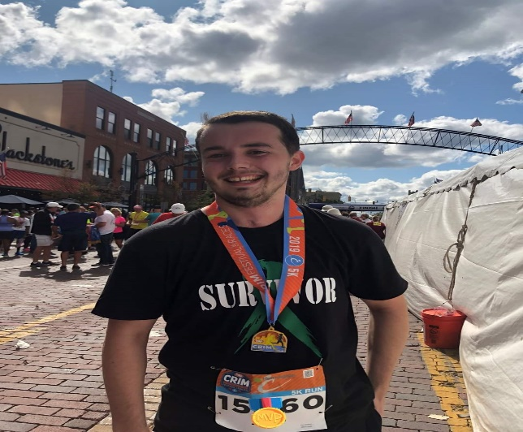

ADMISSION CRITERIA

Spinal Cord Injury (SCI)

POLICY:
The Lighthouse Inc. will admit eligible persons with spinal cord injuries, of all ages, who have high and low tetraplegia, paraplegia, and complete or incomplete injuries. Medically stable individuals with co-morbidities, such as a traumatic brain injury, may be admitted to the appropriate Lighthouse Residential Program.

PROCEDURE:
- Person appropriate for treatment:
- 18 years of age and older for the adult program; 17 years of age and younger for the pediatric program
- The individual with the spinal cord injury requires the unique services of either a specialized interdisciplinary team or rehabilitation specialists.
- The injured individual is in need of residential services with the potential of functional improvement. Residential treatment services provide specialized skills and intensive therapy programs that cannot be provided by local or community care providers.
- The injured individual is medically stable, presenting with medical conditions that are manageable in the residences, as determined by the referring physician, Registered Nurse, and Registered Respiratory Therapist.
- The primary focus of treatment is for physical medicine & rehabilitation, and/or behavioral management.
- Individuals with a support system involved who can assist in a realistic transition plan.
- The injured individual, support system, and/or guardian demonstrate motivation and a willingness to participate in the program.
- The injured individual, support system, and/or guardian are willing to abide by the rules of the program including on and off campus privileges.
- The injured individual will be an appropriate personality match for the residential home. Attributes to be considered include but are not limited to: propensity for disruptive behavior, acuity of medical needs intensity of therapy services and need for coma stimulation programming as assessed by the Clinical Director or their designee.
- The injured individual does not require continual nursing care, isolation or medical restraint.
- Persons with SCI are eligible for admission if the level of spinal cord injury and completeness of injury are determined to be appropriate for the level of care provided by The Lighthouse and The Lighthouse treatment team.

- Typical SCI diagnosis include, but are not limited to:
A) Traumatic spinal cord injury
B) High or low tetraplegia; complete or incomplete
C) Paraplegia; complete or incomplete
D) Medical conditions/diseases affecting the spine or spinal cord resulting in or producing neurological deficits

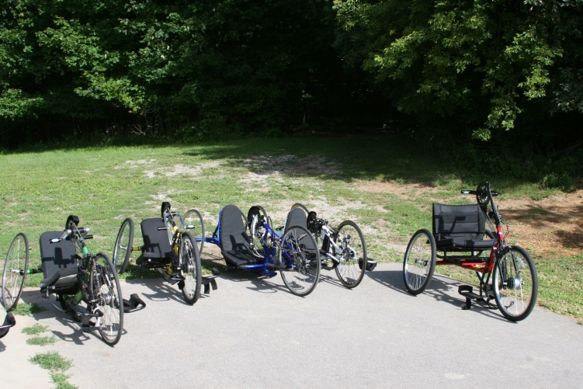

- The etiology of the spinal cord injury or diagnosis will be identified and documented, as the information is made available.

- Prospective residents and guardians are encouraged to tour The Lighthouse Inc. facilities prior to admission to the program.

- Prospective residents or conservator must show the financial resources and ability to meet the charges either by private pay, insurance, or other financial commitment.

- The Clinical Director will annually review the admission criteria for continued appropriateness.

- The Clinical Director will revise the admission criteria as needed and in accordance with the mission and the philosophy of The Lighthouse Inc. program.

- The admission criteria will be documented for public disclosure.

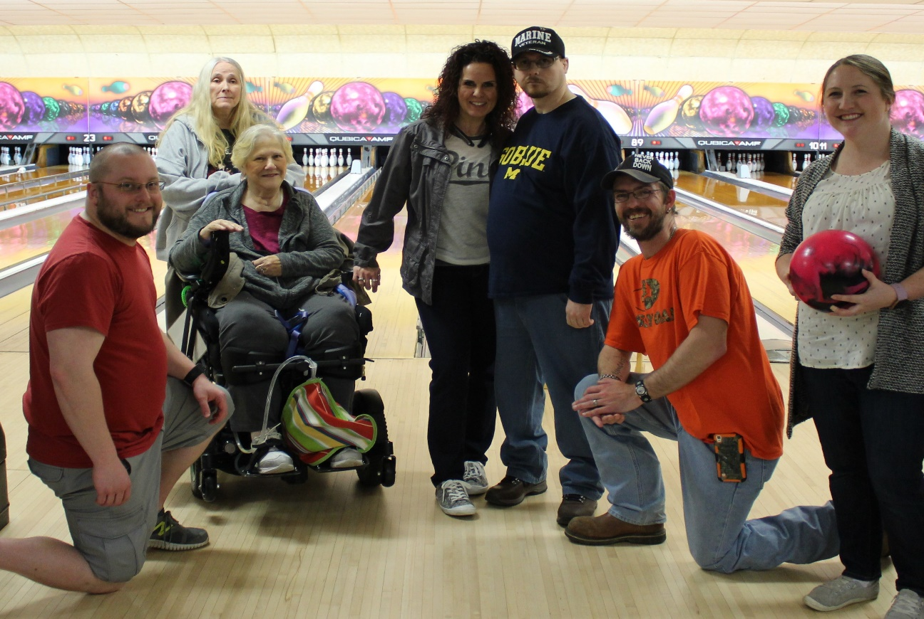

ADMISSION POLICY

POLICY:
Prior to admission, an assessment of medical and rehabilitation needs is completed for each person.

PROCEDURE:
1. Individuals who are hospitalized and who have suffered a TBI or other diagnosis defined in The Lighthouse Admission Criteria are evaluated by the Registered Nurse at the hospital and assessed for the following:
  - Diagnosis and prognosis
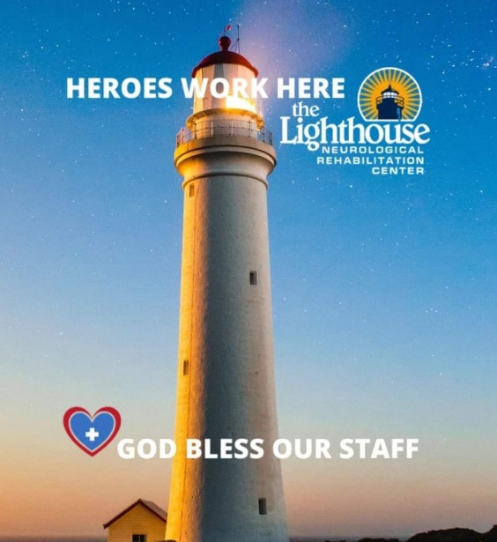
  - Morbidity and co-morbidity
  - Pre-morbid level of functioning
  - Support system
  - Mental status
  - Ability to tolerate rehabilitation program
  - Infectious disease status
  - Eligibility within Lighthouse Admission Criteria Policy
  - Medical History
  - Complications
  - Prognosis
  - Scope and intensity of recommended services
  - Estimated length of stay
  - Additional needs (i.e. equipment, dietary)
  - Funding
  - Potential of the person to benefit from services

- Referrals to The Lighthouse programs are assessed on an individual basis. Referrals of individuals who have not suffered a TBI but meet admission criteria under different criteria may be approved by one of the staff psychologist as well as the management team.

- Referral source is notified when the decision regarding admission is made.

- If the individual meets the admission criteria for The Lighthouse, a written assessment plan, resident care agreement and health care appraisal shall be completed for all residents prior to or on the day of admission.

- The Lighthouse encourages all potential residents to visit the program prior to admission. This is promoted to allow the individual to become familiar with the program, personnel and outline the expectations of both the resident and the facility.

PROGRAM TRANSFER CRITERIA

POLICY:
Transfers to a lesser or more restrictive level of care within the continuum of The Lighthouse, Inc. Programs are contingent on the resident’s appropriateness for treatment.

TRANSFER CRITERIA:
- All persons admitted for residential treatment must meet the criteria established within the Admission Criteria Policy.

- The residential treatment program on campus with 24 hour one-on-one supervision is the first step in the continuum of care. To transition from this program, the resident must meet the following criteria:

  - Demonstrate behavioral or medical stability on all shifts which allows for a reduction of enhanced staffing.
  - Recommendation from treating psychologist and/or Registered Nurse that the individual has reached a level of stability to receive reduction in enhanced staffing.
  - No significant aggression, other maladaptive behavior or medical decompensation within one week of the reduction in staffing.

- When a resident has demonstrated a level of both behavioral and medical stability for a prolonged period of time they may be eligible for the semi-independent living program. Eligibility is determined by the following:

  - Resident is able to demonstrate proficiency in the completion of ADL’s.
  - Resident is employed and/or attending school on a regular basis.
  - Resident is at least 18 years of age or older.
  - Resident has the recommendation from their treating psychologist and, RN. In addition to input from inter-disciplinary team.
  - Resident is able to pass random substance screens, if this is an area of concern, for at least 3 months prior to transition.
  - Resident has demonstrated -0- episodes of physical aggression, sexual inappropriateness or other significantly dangerous behaviors for at least 3 months prior to the transition.

- Residents who have achieved their treatment goals and who would benefit from additional structure and support during the day may be eligible for participation in the Day Program. Transition to Day Program status is predicated on the following criteria:

  - The individual has achieved treatment goals and has the support of the treatment team regarding their ability to participate in the program.
  - The individual is discharged from residential to a community location which is within traveling distance so that they are able to participate in the program without undue fatigue from the daily commute.
  - The individual does not demonstrate behaviors such as physical aggression or that prove to be a danger to themselves or others.
  - The individual has the propensity to benefit from the structured programming and support offered by the day program.
  - The individual has appropriate support in their home setting which allows them to remain in that setting during weekends, and evenings.

- Individuals can transition to Outpatient programming when the following criteria are met:

  - The individual is able to complete their ADL’s without staff assistance or they are accompanied by a support person who will attend the therapies with them and provide the needed assistance in these areas.
  - The individual does not require supervision between therapies or has a support person who attends these therapies with them and who provides the needed level of supervision.
  - The individual is able to administer their own medication if it needs to be taken during therapy times or they are accompanied by a support person who is able to provide their medication for them.
  - The individual does not demonstrate significant maladaptive behaviors which will endanger themselves or others in the area. If the individual is prone to aggressive behaviors, they are accompanied by a support person who is able to address their behaviors in a manner which ensures the safety of all involved.

- Any individual who demonstrates a significant regression in maladaptive behaviors or medical instability may be returned to a more structured treatment status contingent on the recommendations of the individual’s treatment team.
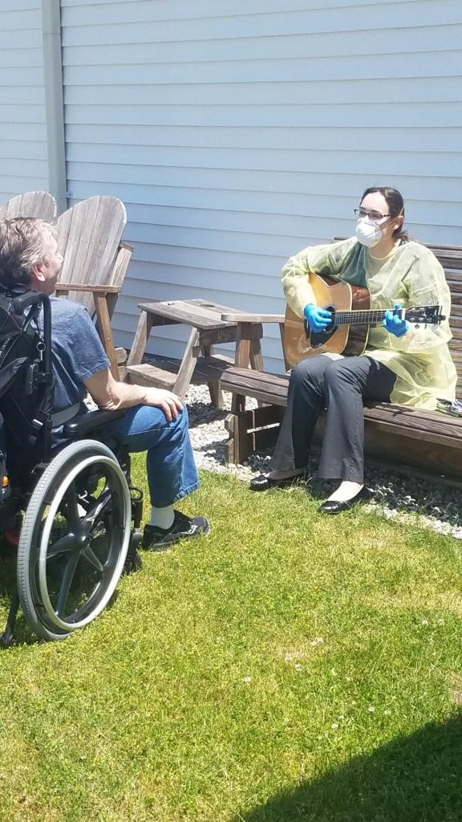

THE LIGHTHOUSE CONTINUUM OF CARE

CONTINUUM AND REFERRALS

POLICY:
It is the policy of The Lighthouse that each resident shall have access to all needed programming, which shall be provided directly by the facility or through a coordinated referral to an external agency.

PROCEDURE:
- The Lighthouse Continuum of Care allows for the provision of the following services internally:
- Nursing Care 24 hour  - Physical Therapy  - Occupational Therapy  - Speech Therapy  - Music Therapy  - Recreational Therapy  - Massage Therapy  - Therapeutic Horseback Riding  - Psychology  - Podiatry  - Neuro Psychological Testing  - Social Work  - Psychiatry  - Physiatrist  - 24-hour Supervision  Other Services Include: | - Structured Behavior Programs  - Medication Administration  - Nutritional Support  - Educational Services  - Activities of Daily Living  - Transportation  - Community Integration  - Vocational Program  - Substance Abuse  - Respiratory Therapy  - Case Management Services  - Independence with ADLs  - ADLs Teaching and Support  - Medical coordination of care  - Orthoses services
- Inpatient Rehabilitation  - Outpatient Program  - Day Programming  - On site primary care services  - On-site Physiatrist services  - Long term care  - Respite services  - Assessment and Evaluation  - 24-hour Trained Staff  - Room and Board  - 24/7 Nursing Availability  - Pediatric Program  - Laboratory Services results in 1-3 days  - Radiography results in 1- 3 days | - Pharmaceutical Services  -Scheurer Pharmacy  -Munson Pharmacy  - Certified Job Coaches  - Neuropsychological Testing  - Individual Therapeutic Activities Program Services (ITAPS)  - Supported Employment  - Volunteer Employment in the  Community and within the  Campus  - Recreational Activities  - Coma Stimulation Program

- The Lighthouse works closely with the following hospitals for emergent care and acute hospitalization services:
  - McLaren Caro Hospital
  - Hills and Dales
  - St. Mary’s Saginaw
  - Munson Healthcare System
  - Mary Free Bed Hospital
  - Covenant HealthCare
  - Hurley Hospital
  - McLaren Bay Region
  - McLaren Lapeer Hospital
  - University of Michigan Ann Arbor
  - Veterans Administration Ann Arbor

- The Lighthouse refers to Covenant HealthCare, Hills and Dales, St. Mary’s, Munson or Select Specialty hospitals for the provision of long-term hospitalization care.

- The Lighthouse provides referral services to Heartland Home Health and Hospice Home Advantage for the provision of home health or hospice services when needed.

- Referrals for neuropsychological services are made with highly regarded community doctors with whom The Lighthouse has a close working relationship. Referrals for other neuropsychological services are set up upon request by residents, guardians and/or case managers.

- The Lighthouse nursing personnel and the internal case manager are responsible for facilitating communication between external service providers and the facility. PIN numbers are obtained for residents who are hospitalized and Lighthouse nurses remain in close communication with hospital nurses regarding resident progress and needs.

- The Lighthouse provides staffing for residents who are hospitalized and provide education for personnel providing treatment regarding each individual’s needs and preferences. Lighthouse staff accompanies all residents to medical appointments internally and outside of the facility. The accompanying staff is responsible for providing education to the medical providers regarding the resident’s injury, preferences, and possible behavioral concerns.

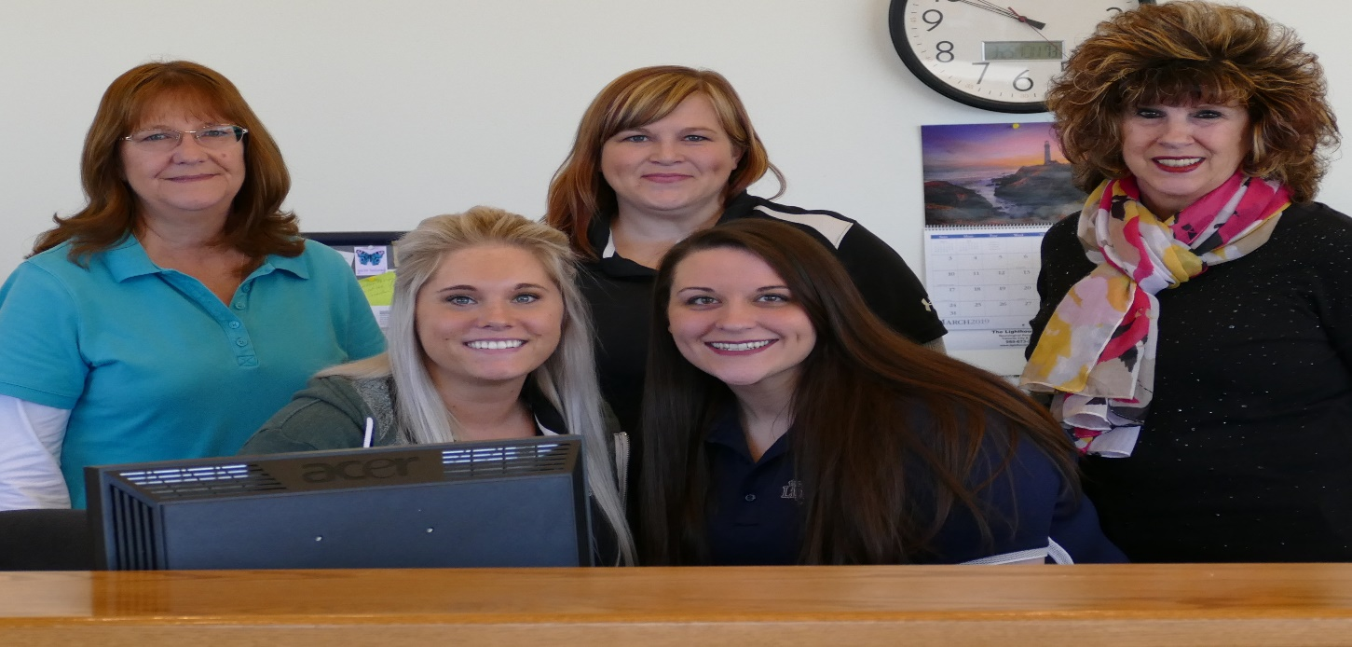

Referrals come to the Lighthouse from a wide variety of community and personal sources, including hospitals, case managers, families, Community Mental Health Agencies, and Department of Health & Human Services. Each inquiry is evaluated by the administration with recommendations based on the individual’s specific needs. Referrals to other agencies or community support services are suggested if admission is not deemed appropriate to The Lighthouse.

The payor sources include insurances, auto no fault, workers compensation, private pay,
Community Mental Health, Department of Health & Human Services, and any other agency approved by The Lighthouse Finance Office. Information on the specific fees is provided upon request to The Lighthouse Finance Office.

The Lighthouse does not discriminate in the provision of service to residents based on race, cultural backgrounds, religion, gender, or sexual orientation. Cultural factors are taken into consideration when designing The Lighthouse program to meet specific cultural needs.

DISCHARGE CRITERIA
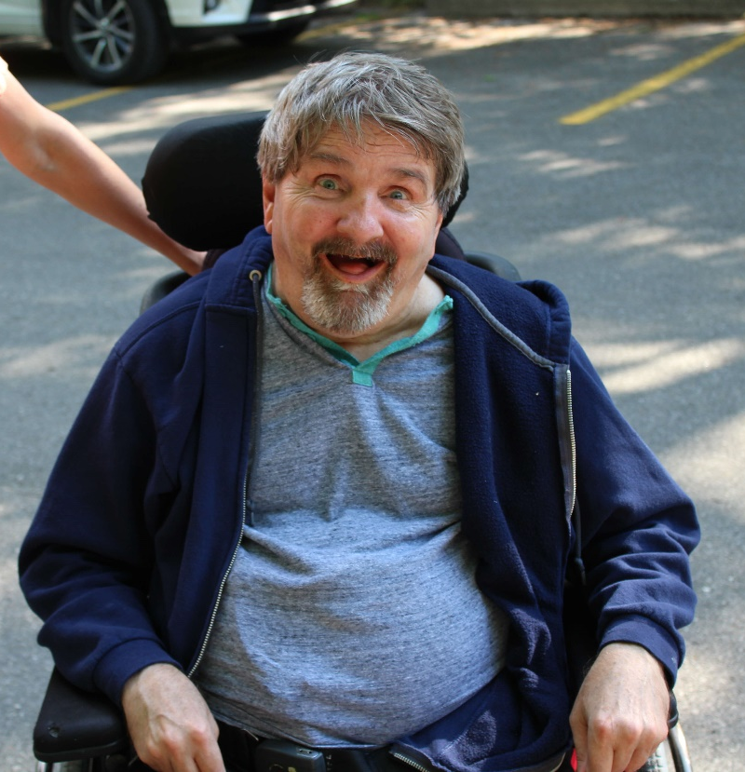
POLICY:
It is the policy of The Lighthouse, Inc. that discharge planning is addressed by the interdisciplinary treatment team. The team provides comprehensive evaluation and treatment with the goal of facilitating the resident’s reintegration into the community.

PROCEDURE:
- Successful Discharge:
  - The resident has received maximum benefit from the program.
  - The resident has been evaluated by the treatment team and it has been determined that the individual no longer requires residential services due to the completion of treatment goals or by consensus of the team that goals will not be achieved in this program.
  - The resident has improved to a level that allows discharge to a different environment, supervised or non-supervised

- Discharge with Subsequent Transfer:
  - The individual has been evaluated by the treatment team and determined to require more intensive care in a different setting such as a psychiatric hospital or the individual, responsible party or other stakeholders have determined transfer to a different treatment facility is needed due to resident choice or financial limitations.

- Discharge Against Medical Advice (AMA):
  - A resident and/or their responsible party wishes to discharge the resident from services against the advice of the treatment team and without adequate discharge planning.
  - The resident and/or the legal guardian acknowledge that they are leaving the program AMA and are aware of the potential adverse consequences.

- Unsuccessful Discharge:
  - The resident experience a major medical or psychological problem that excludes resident benefits from a continued intensive rehabilitation program.
  - The resident has not successfully attained treatment goals and the resident or guardians were noncompliant with agency policies or treatment team recommendations.
  - The resident ability to tolerate the program has been modified and a different setting is needed.
  - The resident and/or their support system are no longer confident in the program.
  - The overall goal of the person’s program has changed so that residential program is no longer the best use of a person’s resources.

- The Clinical Director will annually review the discharge criteria for continued appropriateness.

- The Clinical Director will revise the discharge criteria in accordance with the mission and philosophy of The Lighthouse Inc. program.

- Individuals who are diagnosed with a spinal cord injury will be assessed for specific discharge needs related to their level of injury and completeness of spinal cord dysfunction.

- The discharge criteria will be documented for public disclosure.

DISCHARGE CRITERIA

Spinal Cord Injury (SCI)

POLICY:
Every discharge plan is different and reflects a resident’s unique personal and social situation. Recovery from a Spinal Cord Injury often requires people to receive ongoing therapy after discharge. Discharge plans fall into one of four (4) categories:
a) Discharge home with a referral for home-based rehabilitation services
b) Discharge home with a referral for outpatient therapy or Day Program services, or
c) Discharge to another facility.
d) Unsuccessful discharge
The Lighthouse Interdisciplinary treatment team will address discharge criteria and document discharge recommendations which include each resident’s etiology of injury, level of spinal cord injury, and completeness of spinal cord dysfunction.

PROCEDURE:
- Discharge home:
- The resident has met the goals established on admission or during the course of rehabilitation.
- The resident has reached his/her maximum potential benefits for residential rehabilitation or his/her clinical status has improved. Discharge to home is appropriate, as the resident’s needs may be safely met by another agency or service in the local community.
- Completion of discharge planning may include: providing necessary durable medical equipment and prosthetics; establishing a safe discharge destination and support system; preparing the person served and significant others through education; scheduling follow-up appointments and communicating with other providers for medical, therapeutic, or other required services.
- Documentation completed by the treatment team will include: the etiology of the injury, the level of spinal cord injury, and the completeness of spinal cord dysfunction.

- Discharge with subsequent transfer:
- The resident experienced a significant medical, surgical, or psychological problem requiring acute medical care or another service.
- Transfer facilitated by appropriate personnel in coordination with the treatment team.

- Discharge against Medical Advice (AMA):
- A resident or their responsible party wishes to discharge the resident from services against the advice of the treatment team and without adequate discharge planning.
- The resident and/or the legal guardian acknowledge that they are leaving the program AMA and are aware of the potential adverse consequences.

- Unsuccessful discharge:
- Treatment team has reached a group consensus that the resident is unwilling or unable to participate in the rehabilitation program.
- The Lighthouse Inc. reserves the right to discharge individuals who violate organizational policies and procedures or who decline to participate in the agreed upon plan of care.
- The resident has not demonstrated evidence of improvement in functional abilities or his/her clinical status.
- The overall personal goal of the resident’s program has changed so that residential program is no longer the best use of a person’s resources.
- The resident’s guardian or support system act in a manner, which demonstrates a lack of trust in the treatment program, thus impeding the ability of the resident to benefit from the program.
- The Clinical Director will annually review the discharge criteria for continued appropriateness.

- The Clinical Director will revise the discharge criteria in accordance with the mission and philosophy of The Lighthouse Inc. program.

- Individuals who are diagnosed with a spinal cord injury will be assessed for specific discharge needs related to their etiology of injury, level of injury, and completeness of spinal cord dysfunction.

8. The discharge criteria will be documented for public disclosure.

ADDITIONAL PROGRAMS AND SERVICES

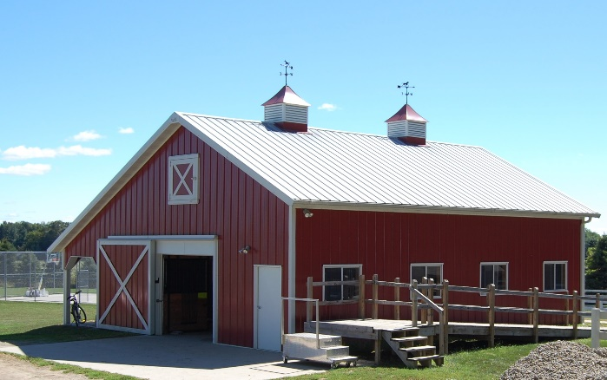
The Lighthouse Therapeutic Riding, Hippotherapy Program
And Equine Facilitated Therapy Program

At The Lighthouse, we offer Therapeutic Riding, Hippotherapy and Equine Facilitated therapy to residents of many different needs and abilities. The Lighthouse in Caro owns four horses, all of whom are housed and cared for by a full time barn manager at our facility. The program is organized and overseen by a Certified Recreation Therapy Specialist, who is pursuing Professional Certification as a member of the Professional Association of Therapeutic Horsemanship International (PATH certified). PATH International is the credentialing organization for accrediting centers and certifying instructors and equine specialists. In Kingsley, residents are driven to a near-by facility, in which the horses are utilized for Therapeutic Riding and Hippotherapy.

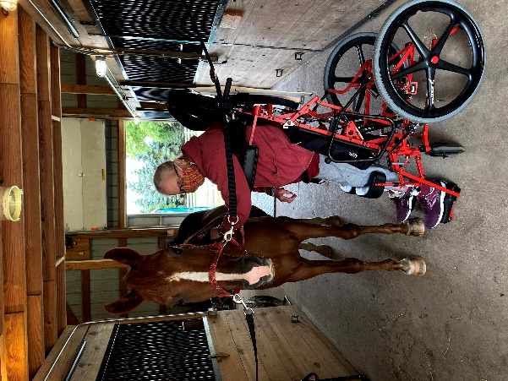
There are several therapists at The Lighthouse who work with the Equestrian program, including Physical Therapy and Occupational Therapy therapists who are Hippotherapy certified. The Lighthouse also employs an Occupational Therapist certified in Hippotherapy. In Caro, our psychology and social work departments also hold sessions at the barn, where bonding with the horses assists in building confidence and enhancing communication skills. During therapeutic riding sessions with Recreation Therapy (CTRS), residents learn skills to become more independent while working with and riding horses, which will aid them towards continual progress of their individual goals and objectives.

In order to take part in the riding portion of the equestrian program, each resident must have a waiver signed by their legal guardian on file and must also be deemed physically fit to ride by their doctor. Waivers are updated annually. The program has adaptive equipment for riding; each participant is fitted for a helmet and gait belt. At The Lighthouse, we are committed to finding the equipment and horse that is the best fit for the resident and will facilitate positive therapy outcomes.

The equestrian program is offered to residents all year long in Caro. The riding season at both typically is May 1st through October 31st of each year, weather dependent. Many of the Caro therapists take advantage of the “grooming” portion of the program, and bring residents to the barn in the off season for some time outside of the therapy center. Grooming sessions create a unique opportunity for our residents to get up close and personal with a horse, while learning about equine care and creating a special bond.

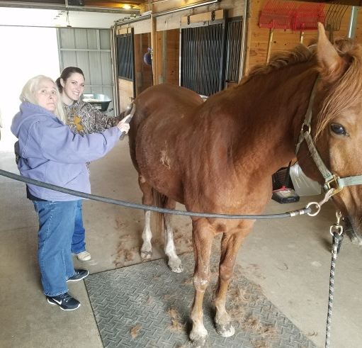
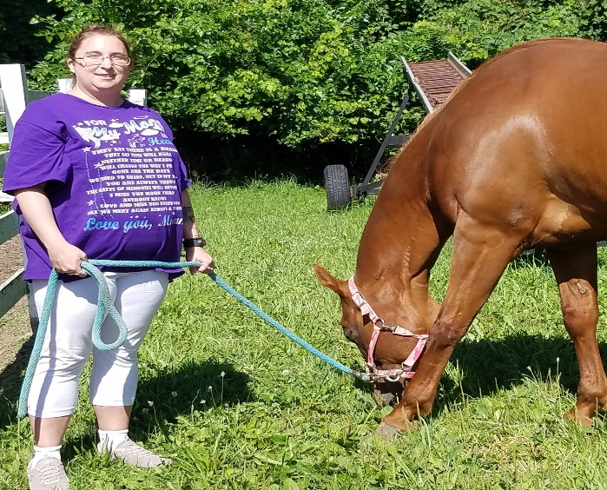

Adaptive Sports Program at The Lighthouse
Adaptive sports are traditional sport activities, but with the addition of individualized modifications to meet the needs of individuals with physical or cognitive deficits. Adaptive sports programs assist in helping the resident develop confidence and benefit from the added health advantages of increased physical activity and/or involvement in a variety of social activities. Health benefits may include: reduced pain, decreased stress, and improved emotional well-being, as well as a greater sense of independence, and self-confidence.

The Adaptive Sports Program at The Lighthouse is a rapidly growing program that is headed by the Recreational Therapists. Highlights of the program are the Return to Hunting segment and Adaptive Paddling.

In the Return to Hunting segment, Recreational Therapists, who are State of Michigan Certified Hunter Safety Instructors, help sportsmen/sportswomen participate in Michigan’s wild-game hunt season. Participants of this program’s segment were hunters before their injuries or medical conditions occurred.

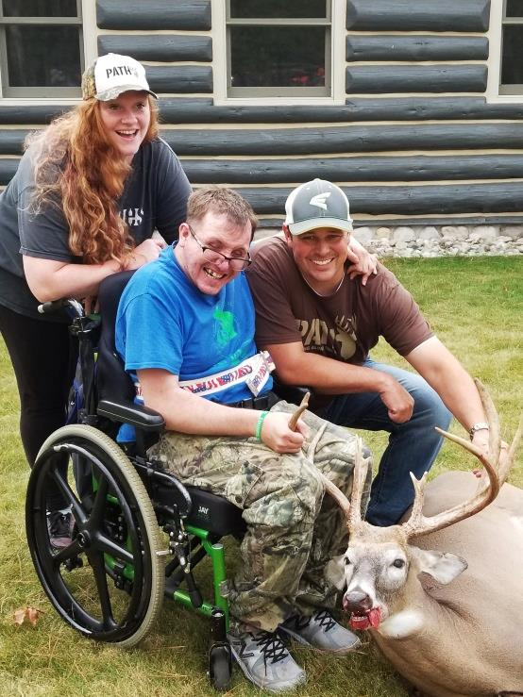
The Adaptive Paddling Segment provides The Lighthouse residents the opportunity to safely enjoy kayaking activities in local waters. Kayaking activities are supervised by a Recreational Therapist certified in adaptive kayaking, with training through the American Canoe Association. In Kingsley, residents can also try adaptive standup paddleboarding!

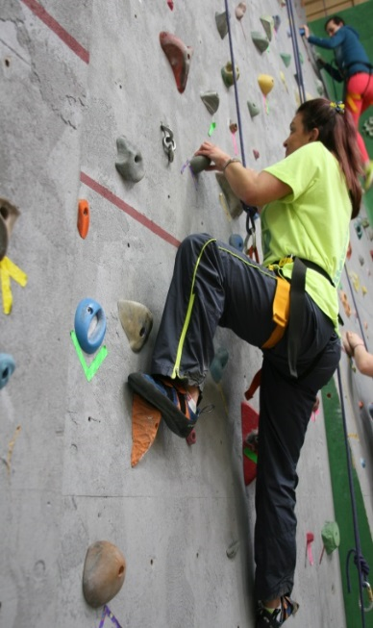
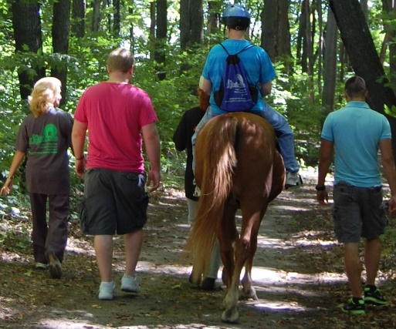

The Adaptive Sports Program at The Lighthouse has helped residents participate in a variety of athletic opportunities, some examples include: cycling, paddling, fishing, hunting, shooting, hiking, yoga, skiing, archery, boccia, equestrian riding, boating, bowling, basketball, rock climbing, and aquatics.

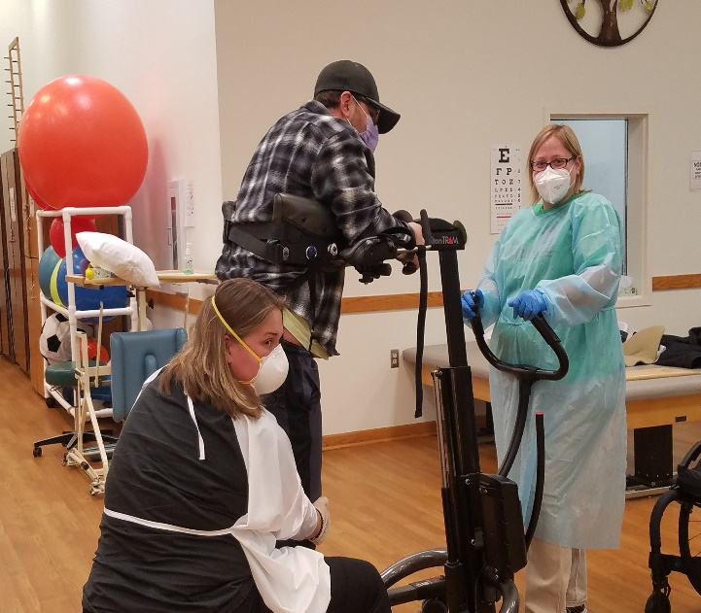

Orthotics and Prosthetics
Prosthetics and Orthotics is the assessment, production, and custom fitting of artificial limbs and orthopedic braces. The Physical and Occupational Therapists provides comprehensive training and education for the resident’s orthotics and/or prosthetics using the following plan of care:
Resident Assessment
- Perform a comprehensive assessment of the resident
- Obtain an understanding of resident's orthotic/prosthetic needs

Form/Manage Treatment Plan
- Consult with an Orthotist/Prosthetist
- Create a comprehensive orthotic/prosthetic treatment plan to increase stabilization and function
- Diagnostic fitting
- Assessment of intervention
- Functional exercise plan
- Gait training
- Functional training for daily living
- Patient education and instruction

The Lighthouse’s network of providers includes an Orthotist and Prosthetist. The therapist works in continual collaboration with either the Orthotist or Prosthetist to meet resident’s on-going needs.

Pedorthic Service
Pedorthic service is an extension of Orthotics and Prosthetics; where an Orthotist works in conjunction with the Caro Physical and/or Occupational Therapist to prevent or alleviate foot problems caused by congenital defects or an injury. The Orthotist will design, manufacture, modify, and fit corrective footwear. The Physical and Occupational Therapist will manage new footwear referrals, wearing schedules, and the replacement process.

Substance Abuse Group Therapy
Group therapy sessions are provided on a weekly basis to assist those individuals who have been diagnosed with a Traumatic Brain Injury and substance abuse disorder, including but not limited to alcohol, marijuana, narcotics or other substances. At The Lighthouse, substance abuse groups are led by trained psychologists or social workers. The group therapy goals are to enrich members with insight and guidance. Group therapy and addiction treatment are natural allies. In accordance with SAMHSA guidelines, there are several models of treatment incorporated in the substance abuse groups:
- Psychoeducational groups teach about substance abuse.
- Skills development groups help members hone skills necessary to break free of addiction.
- Cognitive–behavioral groups encourage members to rearrange patterns of thinking and action that lead to addiction.
- Support groups which provide a forum where members can debunk excuses and support constructive change.
- Interpersonal process groups enable members to re-create their past and rethink problems and solutions that led to their substance abuse.

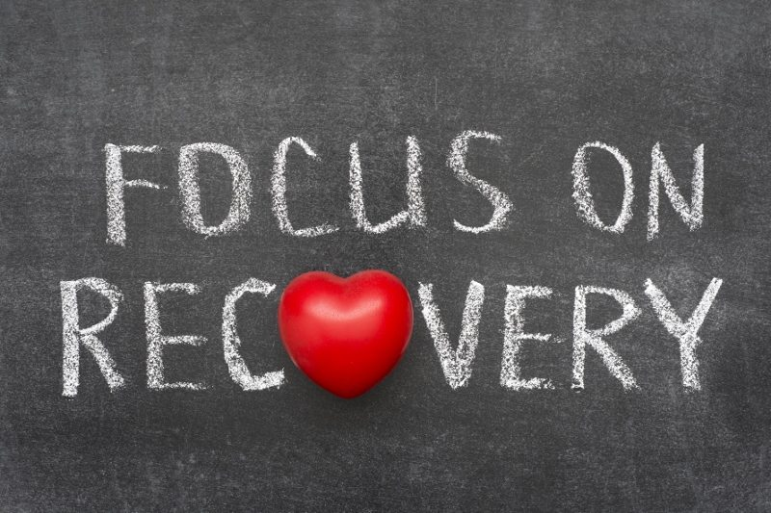

The group therapy approach is used to provide positive peer support and reduce the sense of isolation that many people who have substance use disorders experience. In addition to enabling participants to identify with others who are struggling with the same issues, the group process allows members to witness the recovery of others. The SA groups help members learn to cope with their traumatic brain injuries and substance use problems by allowing them to see how others deal with similar problems.

Vocational Program
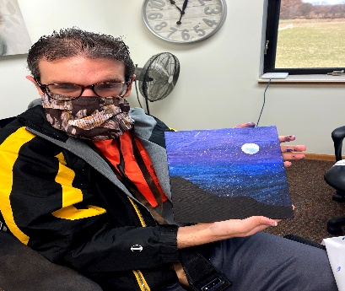
The Lighthouse, Inc. provides a full continuum of vocational services to residential and day programming participants. These services include a pre-vocational workshop, Level I and Level II (paid, on-site, Enclave services), and community based paid employment. In addition, The Lighthouse facilitates volunteer employment for residents who demonstrate an interest in working within a specific realm where paid employment may not be available. The Vocational Program provides educational support for completing applications, writing resumes, and interview skills. The following levels of the Vocational Program assist each resident’s needs in exploring individual career opportunities by identifying interests, skills, abilities, limitations, and alternate ways to perform each job task given to them.

The Lighthouse Pre-Workshop
The Lighthouse has a pre-vocational workshop. This program offers training and the opportunity to develop the skills needed to return to community based employment.
This level works on:
- Life training skills
- Projects, crafts, and activities to enhance the quality of leisure time and promotes social skills
- Attendance and motivation to complete simple tasks and individual projects

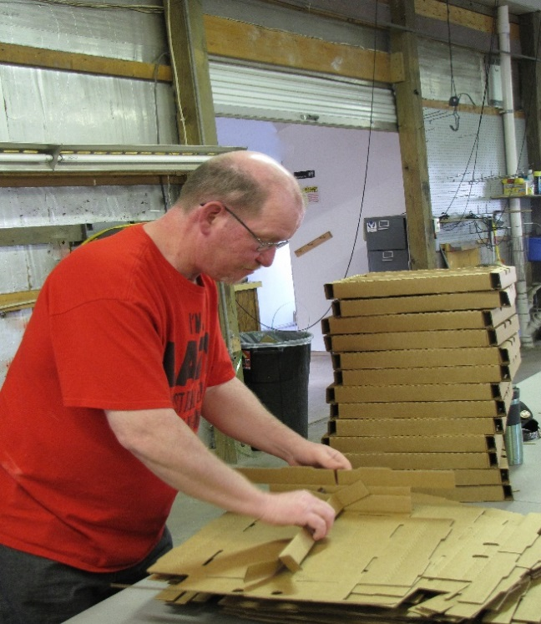
The Lighthouse Enclave Program
If a resident completes the pre-vocational workshop, they are then able to move to the Enclave Program. Advancement to the Enclave Program is decided by The Lighthouse team. The Enclave program provides the resident with the opportunity to participate in several different jobs around The Lighthouse campus. These jobs include landscaping, car wash, janitorial work, and animal care. Residents are able to be trained by experienced staff and learn new skills, while being paid. Level I and Level II offer different supervision with the goal of successfully achieving the skills needed for the resident to advance to the next step of employment. Enclave training includes:
- Attendance
- Decreasing amount of verbal and physical cues
needed to finish a job task thoroughly
- Motivation
- Time management
- Initiative
- Good work ethic such as appropriate social
interaction when working with peers and their
supervisors
- Appropriate dress
- Individual needs for support
- Decrease amount of supervision needed
- Provide job description and set goals
- Problem solving skills

Assistance Seeking Employment
Once a resident has met the requirements from the Vocational Enclave program, the team will assess each resident individually to decide when it is appropriate to begin the community job search process. The Lighthouse Supportive Employment Services assists each individual in seeking community based employment by supporting accommodations needed for the individual, helping to expand their professional skills, and continuing to set and meet personal goals. Provide support include:
- Proficiency in compiling needed information to complete a resume
- Resume writing
- Gathering, completing, and turning in job applications
- Interview needs
  - Appropriate dress
  - Practice interview questions and answers
  - How to present yourself as an individual
- Compile a profile appropriate to a resident’s needs and interest

Volunteer and Community Employment
The Lighthouse offers the support residents need to be successful in maintaining employment. Some placements are independent, with the resident performing their duties under normal supervision. Other jobs require a job coach to be assigned to work with the employee, to train, prompt, and supervise the resident/employee. Job coaches will recommend and promote alternative methods to complete difficult tasks and duties. At this level of employment, support is continued in all areas of the job, with the goal for residents to be successful in community based employment.
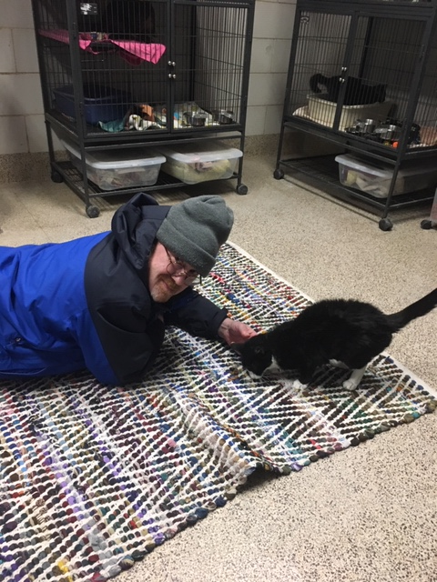
Vision Therapy
The Lighthouse Rehabilitation Center in Kingsley offers a Vision Therapy Program. Often visual problems resulting from traumatic brain injury are overlooked during initial treatment of the injury. Frequently these problems are hidden, lengthening and impairing rehabilitation. Vision is the most important source of sensory information. Consisting of a sophisticated complex of subsystems, the visual process involves the flow and processing of information to the brain. Because there is a close relationship between vision and the brain, traumatic brain injury can disrupt the visual process, interfering with the flow and processing of information. The result is a vision problem. Symptoms indicating a vision problem are:
- Blurred vision
- Sensitivity to light
- Reading difficulties; words appear to move
- Comprehension difficulty
- Attention and concentration difficulty
- Memory difficulty
- Double vision
- Aching eyes
- Headaches with visual tasks
- Loss of visual field
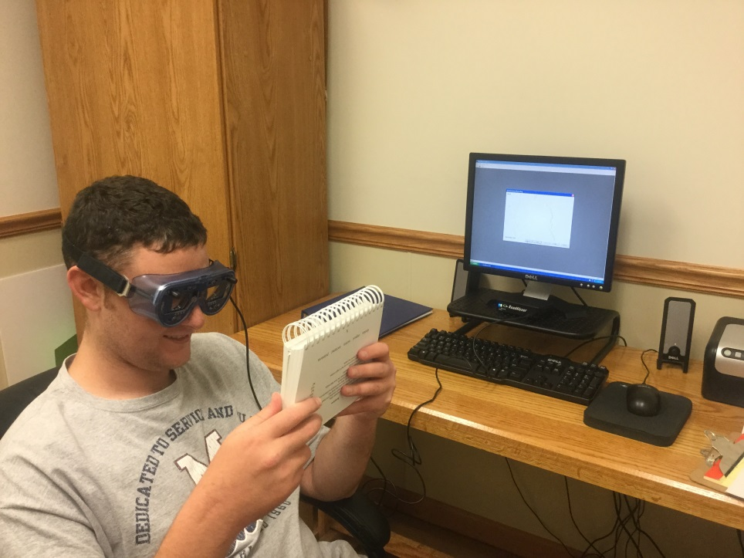
Good visual skills are necessary for efficient information processing. When processing visual information is difficult, one may "try harder," straining without even knowing it because the effort is subconscious. If the visual system is inefficient, every task can seem difficult, using more energy than required. Visual skills affected by traumatic brain injury include but are not limited to: tracking, fixation, focus change, depth perception, peripheral vision, binocularity, maintaining attention, visualization, near vision acuity, distance acuity, and vision perception (The Optometric Extension Program, 2013).
Vision therapy can develop and/or improve basic visual skills and abilities, as well as the comfort, ease, and efficiency of eyesight, enjoyment of reading and visual thinking as well as many other activities in daily living.

Initially an Occupational Therapist will complete a visual screening. If necessary, the resident will be referred to an Optometrist for further evaluation. Once seen by the Optometrist, the Occupational Therapist and Optometrist will collaborate together and treat the visual deficit.

Vision Therapy Modalities:
- Prescription lenses
- Therapeutic lenses
- Prisms
- Optical filters
- Eye patches or occludes
- Electronic targets with timing mechanisms
- Computer software
- Vestibular equipment
- Structured activities that enhance visual perception

The Occupational Therapist will work with a multidisciplinary team including physical, speech, recreational, and music therapists in order to address the visual perceptual and visual motor components, including but not limited to balance, vestibular, cognition, and comprehension. The Occupational Therapist will develop a treatment plan targeting visual deficits and formulate measurable goals in order to achieve functional outcomes. The treatment plan will be evaluated approximately every 12 weeks in order to measure progress and to adjust the treatment plan to meet resident’s goals. Residents will typically be seen for 30 to 60 minute sessions 1-3 times per week, with flexibility to meet each resident’s specific needs.

VitalStim Therapy

Neuromuscular Electrical Stimulation (NMES)
Dysphagia is the medical term used to describe difficulty swallowing. Dysphagia includes difficulty starting a swallow and the sensation of food being stuck in the neck or chest. Dysphagia is common with residents who have suffered a traumatic brain injury, stroke, or normal aging.

Licensed Speech and Language Pathologists are trained to identify and treat dysphagia. A licensed Speech and Language Pathologist, and certified in VitalStim Therapy may administer neuromuscular electrical stimulation (NMES). NMES is the use of electrical stimulation to aid muscle strength and function, wake up the nerves, and rehabilitate the process of swallowing.

The Lighthouse employs three NMES Certified Speech and Language Pathologists who are skilled VitalStim practitioners. A typical VitalStim treatment plan begins with an evaluation and an individualized treatment plan that is generally 4-8 weeks in duration.

Tai Chi
Tai Chi is a non-impact exercise that works on strengthening the body with minimal stress to the joints. Tai Chi exercises help to improve flexibility, coordination, dynamic balance, postural alignment, body awareness, and neuropsychological functions (memory and attention). Tai Chi also facilitates mindfulness and a state of relaxation. Tai Chi is a therapy option at the Caro Lighthouse. Both Physical and Occupational Therapists have attended courses and successfully attained the basic knowledge for practicing Tai Chi in the clinical setting.
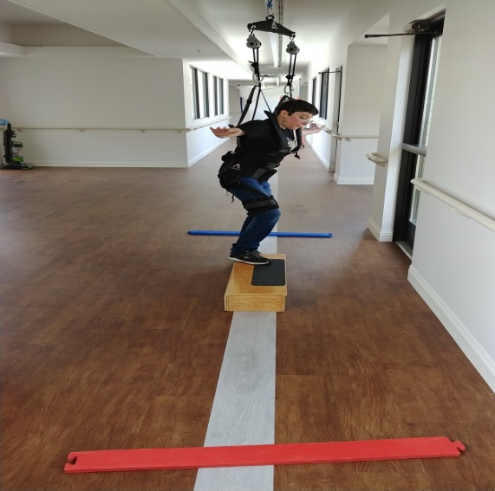

Zero-G
The implementation of the Zero-G into the Physical Therapy practice in Caro has provided The Lighthouse Physical Therapists with the opportunity to advance the treatment of orthopedic residents with a traumatic brain injury. This system allows the therapist to unweight the resident and reduce the pressure in the bilateral lower extremities. The technique allows the therapist to provide gait training to residents who have significant weight bearing limitations or residents who present with a severe TBI and/or a Glascow Coma Scale of 10 and below. The Zero-G provides a safe and controlled environment for training, working on the gait cycle, standing tolerance, and balance.

Trauma and EMDR Therapy
(Eye Movement Desensitization and Reprocessing)
EMDR therapy is an extensively researched, effective psychotherapy method proven to help people recover from trauma and other distressing life experiences, including PTSD, anxiety, depression, and panic disorders. The Lighthouse psychology department employs a Level 2 EMDR therapist for additional therapeutic services.

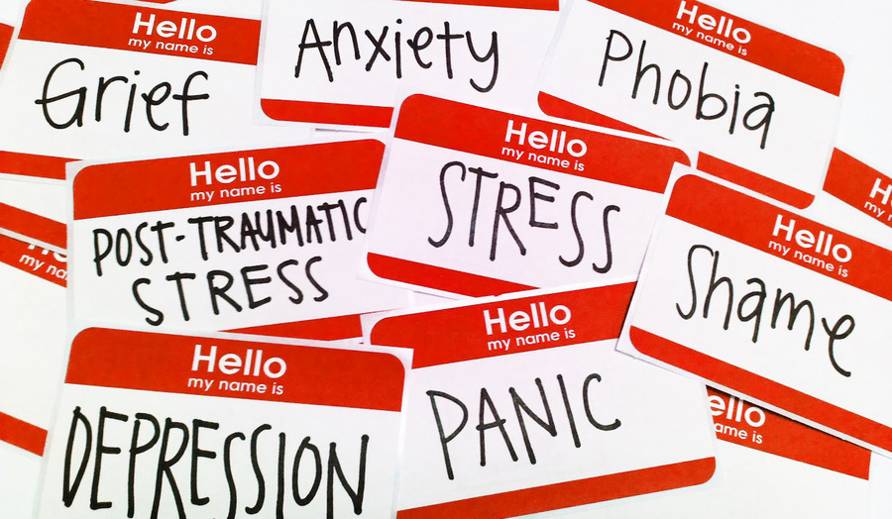

Brain Injury Support and Education Group

Families, Caregivers, and Friends
The Lighthouse offers a free support group for families and friends affected by a traumatic brain injury. The program is designed to help loved ones learn to cope with the new norm, of living with a traumatic brain injury.

Learning to cope with a traumatic brain injury may be the biggest challenge ever faced by a patient and their family/friends. It is good to know that you are not alone in such a difficult situation. The Lighthouse offers a weekly support group to provide the opportunity to make friends with people undergoing similar challenges and also the opportunity to learn more about traumatic brain injury and how to cope with it. Just as important as the patient’s well-being is the well-being of his or her support system. This includes family, friends and caregivers. It is easy for the loved ones of a brain injury survivor to get engrossed in caring for that individual and putting their own needs and wants aside.

Benefits of participating in The Lighthouse TBI support group meeting include presentations by specialty speakers, referrals to local resources, and emotional support from others in similar circumstances. This support group enables individuals to exchange ideas in a confidential atmosphere where both positive and negative views can be expressed without being judged. This group is open to the public.

Other Services
Phlebotomy services are provided by The Lighthouse. With the convenience of on-site phlebotomy, residents are able to follow doctor orders for lab work efficiently.

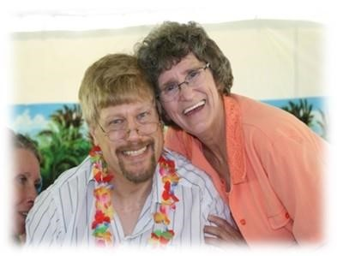
OUR TREATMENT TEAM

Chief Executive Officer
Our Chief Executive Officer (CEO) has over 30 years of experience with traumatic brain injury, first as mother and the primary caregiver of a behaviorally challenged brain injured son. She oversees the treatment team and is ultimately responsible for ensuring each resident receives proper treatment.

Clinical Directors
Our Clinical Directors oversee the clinical therapeutic environment and consult on various professional issues. The Clinical Directors work in conjunction with other team members on developing and maintaining treatment plans. Clinical Directors assist the CEO in the decision-making processes of The Lighthouse.

Medical Directors
The Medical Directors provide leadership in establishing a basis for medical treatments for inpatients, outpatients, and day programmers. They oversee each resident’s medical regimen, providing guidance in the development of a comprehensive medication treatment plan utilizing the least amount of medications possible. The Medical Directors advocate for individuals with activity and other limitations. They provide psychiatric consultation services and involves persons served, families, and/or significant others in education regarding identified diagnosis and treatment recommendations. They also help the organization’s adherence to the ethical conduct by assisting the nurses, psychologists and social workers.

Rehabilitation Directors
The Rehabilitation Directors collaborate with the treatment team, and define the composition and duration of the individual’s treatment program. They ensure the plan of service is consistent with individual predicted outcome.

Psychologists
The Psychologists provide individual psychotherapy dealing with such issues as social-emotional adjustment, frustration tolerance, anger management, brain injury education, coping skills, and deficit awareness. They help design and monitor individual behavior programs. Supportive counseling to families as well as consultation to staff is also made available from the Psychologists.
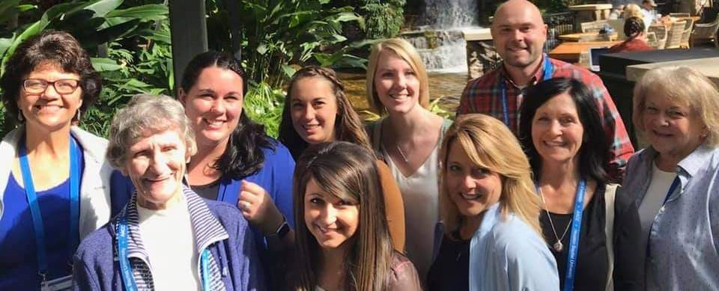

Social Workers
The Social Workers provide supportive therapies, including individual and group, to the resident and family to facilitate social and emotional adjustment. Social Workers provide education on TBI to residents and families. They work with the psychologist and therapists to formulate, coordinate, and implement individual plans of services and provide a link that ensures the involvement of family members and/or responsible parties. In Caro, they also provide school liaison services to ensure a comprehensive educational program is established for every child and adolescent.
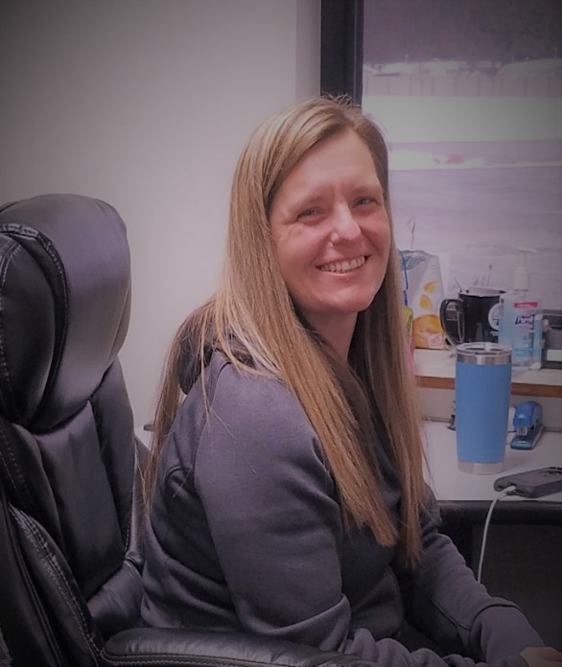

Registered Nurses
The Registered Nurses are responsible for all administration and supervision of the medical aspects of The Lighthouse program. They provide nursing assessment and care, participate in treatment planning, and work directly with residents. The Nurses provide and coordinate the medical and psychiatric services for the residents by consulting with the Executive Director, Clinical Director, Medical Director, and the Psychologists. They oversee the administration of daily medications as well as manage the medical services for residents by administering and/or supervising special medical procedures as directed by the physician.

Physical Therapists
The Physical Therapists use a variety of evaluative and treatment approaches to help residents achieve the fullest potential possible. Emphasis is placed on function, strength and quality of movement. Assistive device evaluation is also provided.

Our Physical Therapists evaluate each resident and design a treatment program which may include the following:
Aquatic Therapy in the Rehab Pool
- Individual Therapy Session

Manual Therapy
- Mobilization of the spinal, extremity, soft tissue, and myofascial release techniques

Exercise Programs
- Therapeutic, postural, progressive resistive exercises
- Neuro muscular reeducation
- Stabilization programs

Modalities
- Ultrasound
- Muscle and Low Voltage Stimulation
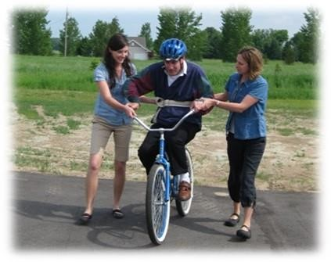
- High Voltage Galvanic Stimulation
- TENS
- Moist Heat/Ice Pack
- Traction
- Muscle Reeducation
- Wheelchair Management and Training
- Therapeutic Massage
- Phonophoresis
- Combo therapy (Ultrasound & Electrical)
- Paraffin Wash Bath

Gait Training
- Non-weight Bearing
- Partial Weight Bearing
- Weight Bearing as Tolerated

Balance Training
- Standing
- Sitting
- Dynamic Balance

Physical Therapist Assistants
Our Physical Therapist Assistants work closely with the Physical Therapists to assist the residents in increasing independence with movement of extremities. Focus is placed on balance, posture, function, strength and quality of movement.

Occupational Therapists
Occupational Therapists work closely with residents to increase independence in activities of daily living, including personal hygiene, bathing, dressing, cooking, feeding, and use of adaptive equipment. Skills such as money and time management, work skills and behaviors, problem solving, community safety issues, and memory are also addressed to help the resident obtain maximum potential.

Our Occupational Therapy staff assists individuals to improve their cognitive and physical skills in preparation for independence at home, school and the workplace. The treatments are individual, and may include the following:

Cognitive-Perceptual Retraining
- Visual-perceptual and visual-motor skills such as eye hand coordination
- Visual scanning and localization
- Cognitive skills such as Organization & planning, gathering & processing information, functional math and money management, reasoning and problem solving for real life situations.

Activities of Daily Living Skills
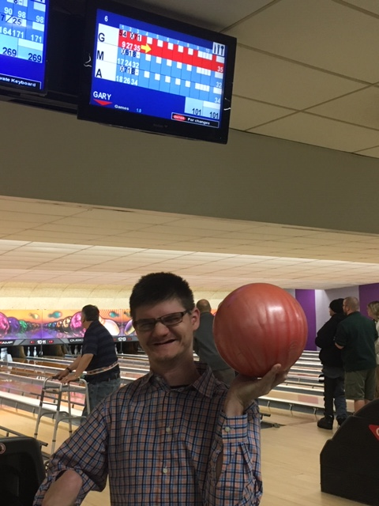
- Relearning daily activities such as eating, bathing, dressing, grooming, home management, community living skills, adaptive equipment
- Compensatory strategies for physical and cognitive dysfunction
- Transfer training from chair, bed, tub, shower, and car

Neuro Re-education
- Balance, head, neck, trunk control coordination, range of motion and strengthening for impairments in upper extremity function,
- Endurance
- Craniosacral or Myofascial release techniques
- Sensory Interpretative techniques

Speech Language Pathologist
Speech Language Pathologists work with residents with impaired cognitive and communication skills impaired by brain injury or other disorder. The Speech Therapist help to restore or compensate for lost speech, language, cognitive, and swallow functioning. When oral communication is unattainable, the Speech Therapist helps the resident learn to use alternative communication methods.

Speech Therapists assist individuals with difficulties in swallowing, speech, thinking, understanding, cognition and communicating effectively in the following techniques:

Treatment Techniques
- Articulation Cognitive Therapy
- Dysarthria/apraxia • Memory,
- Voice/fluency • Problem solving and reasoning
- Oral motor exercises • Executive functioning
- Mental flexibility
Language Therapy
- Planning and organization
- Verbal expression • Attention to task
- Receptive language • Information processing
- Programming skills • Orientation
- Dysphasia treatment

Attention/Augmentative
- Setting up communication device and management

Recreational Therapists
Recreational Therapists strive to meet rehabilitative and leisure needs of all persons limited in opportunities by training and equipping the resident to achieve his/her optimum level of abilities. They provide opportunities for success by engaging in activities of creative self-expression, social development, self-awareness, and learning intellectual development essential to the rehabilitation process and community reintegration

Massage Therapist
A Massage Therapist is someone who is trained and skilled in massage therapy for medicinal benefits. Massage therapy is the manipulation of the soft-tissue and muscles of the body and it is used for many different reasons. Among the reasons for massage therapy is to relax overworked and tired muscles, to treat pain that results from any number of ailments, to aid in the rehabilitation of athletic injuries, and to support overall good health. The Massage Therapist will work in collaboration with the other therapists to improve muscle function as well as assist with stress reduction.

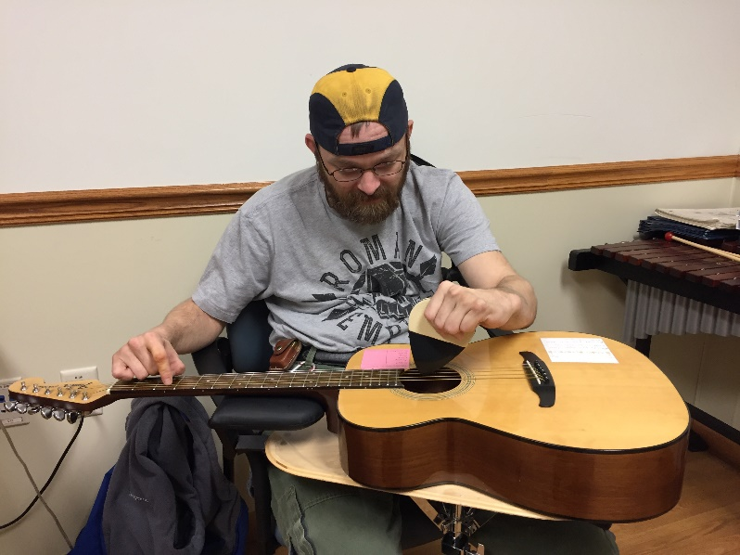

Music Therapist
Music is an ideal therapeutic tool because of the special place it holds in our day-to-day lives. We all use many forms of musical experience (listening, playing instruments, singing, moving to music, creating and discussing music to relax or energize) to teach, to express feeling, to stimulate memories and to bring us closer to one another. The Music Therapists are trained to structure all these aspects of music experience to improve communication and to promote social, emotional, motor and cognitive development.

Vocational/Workshop Directors
Vocational and Workshop Directors are specially trained in vocational development, supportive employment, job coaching, and time management studies. The Lighthouse has a Vocational program that addresses vocational development, supportive employment, job coaching, and time management studies. Residents are individually evaluated for strengths, weaknesses, and abilities as related to employment potential. The Vocational and Workshop Directors participate in interdisciplinary team with insights into the functional areas of the residents.

Program Directors

Program Directors facilitate communication across the continuum of care and are instrumental in planning and training services.
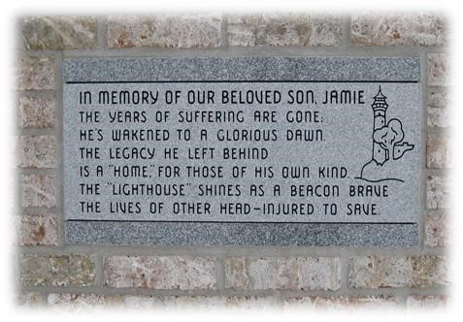

Rehabilitation Aides
The Rehabilitation Aides provide quality personal care, implement behavior plans, structure actives, attend medical appointments, assist in the completion of therapeutic actives and provide ongoing supervision and support. Based on the resident’s medical acuity, the Rehabilitation Aides will receive additional training to provide extra care for trachea, IV antibiotics, bowel and bladder training, and dysphasia guidelines for a resident’s diet.

Home Managers
The Home Managers work with the interdisciplinary team to effectively manage the residential homes to oversee all resident care needs. They ensure the provision of quality personal care, implement behavior plans, oversee activity schedules, attend medical appointments, manage medication administration, assist in the completion of therapeutic activities, and provide ongoing supervision and support to motivate staff to do their best. Home Managers effectively oversee the day to day operation of the home on a variety of different ways including in keeping the homes clean and orderly as well as coordinating the transportation needs of the residents.

Medication Technicians
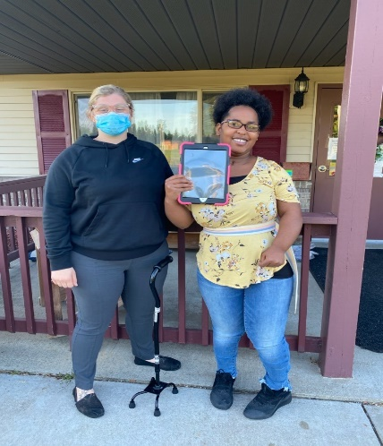
The Medication Technicians work with the interdisciplinary team to effectively administer medications appropriately and accurately. Medication Technicians assist the Home Managers in the day to day operations of the home. They provide quality personal care, implement behavior plans, structure actives, attend medical appointments, assist in the completion of therapeutic actives, and provide ongoing supervision and support. Medical Technicians follow all doctor orders pertaining to medication needs for residents. They oversee all relevant documentation of medication distribution to each resident. Based on the resident’s medical needs, the Medication Technicians will receive additional training to provide extra care for trachea, IV antibiotics, bowel and bladder training, as well as dietary and dysphasia guidelines.

Rehab Specialists
Our Rehab Specialists provide leadership in coordinating the complex rehabilitation services of inpatients, outpatients and day programmers. They are responsible for the assessment of rehabilitation needs for identified residents and present findings in a manner understandable to the person served for prognosis and discharge. They work in collaboration with the treatment team in defining the duration of the individual’s treatment program to help ensure the plan of service is consistent with the individual’s predicted outcomes. The Rehab Specialists also provide medical care directly or through arrangements with other physicians. This includes care for continuing, unstable or complex medical conditions.

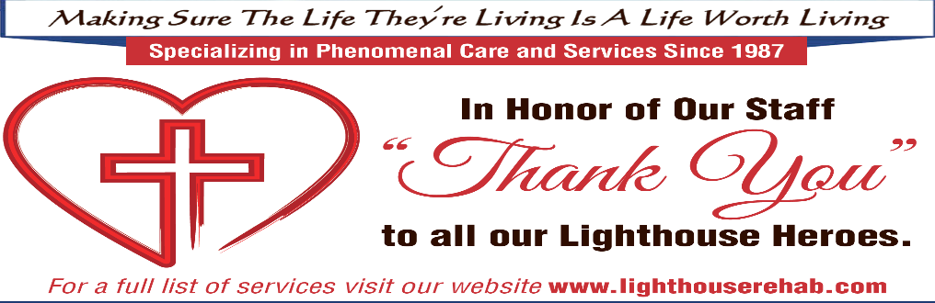

Community Based Services
Community-based services aid our aging community and individuals with physical and cognitive deficits to maintain independence, to the fullest extent possible. Maintaining one’s independence may mean remaining in the comfort of one’s own home or residing in a semi-independent living arrangement.
Community-based services may be provided by a number of service providers.
Region VII Area Agency on Aging: Partner with local organizations to provide….
- Access Services
- Community Services
- In-Home Services
Thumbody: Public transportation providing service to….
- Caro
- Indianfields Township
- Almer Township
- Limited service to Cass City, Mayville, and Vassar
Fresenius Medical Care: Offers dialysis treatment and support for individuals living with chronic kidney disease and ESRD.
- Caro
Kingsley: BATA System

