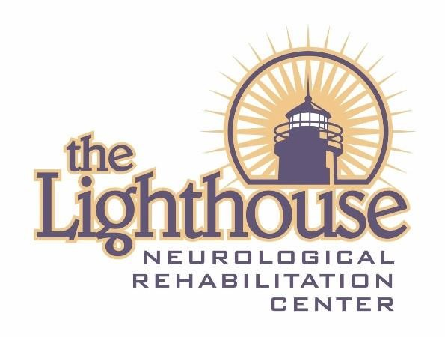

Outpatient
Scope of Services

The Lighthouse Campuses
2020

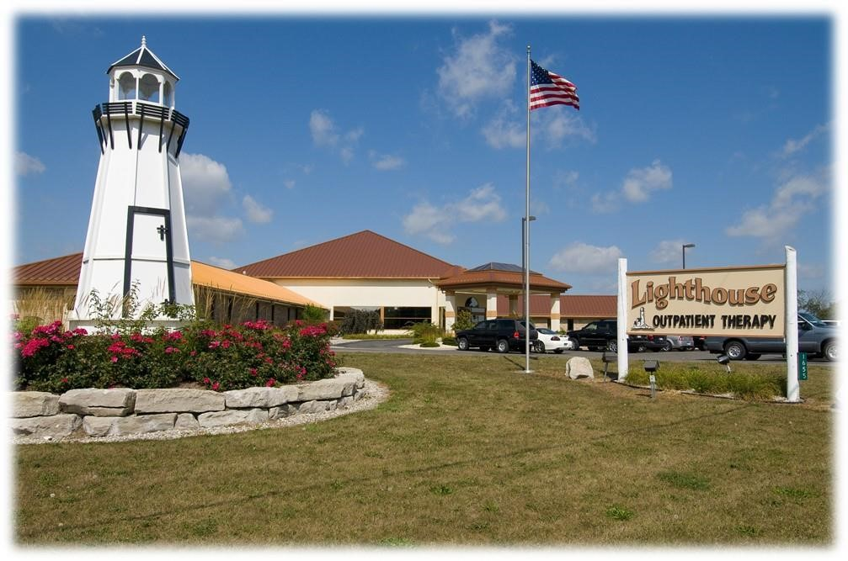
Caro, MI

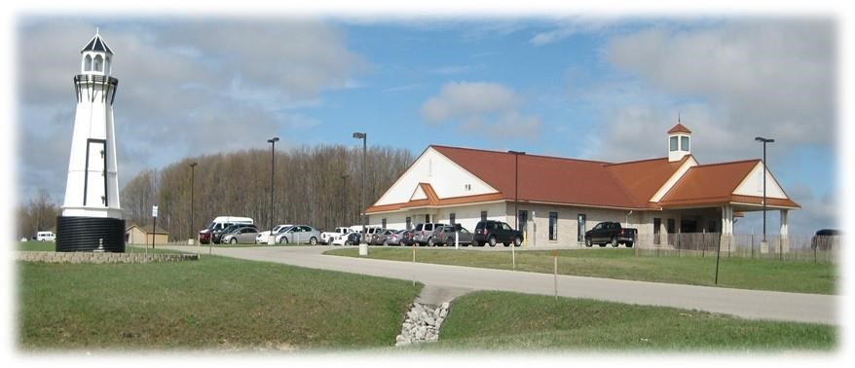
Kingsley, MI

OUR MISSION

The Lighthouse provides phenomenal care, treating every resident as we wanted our son to be treated.

OUR CORE VALUES

- Glorify God in all that we do
- Serve every person with excellence
- Do unto others, as you would like them to do unto you
- Honesty and integrity in dealing with our families, payors, and employees

OUR TREATMENT PHILOSOPHY

The Lighthouse recognizes each patient is a whole person made up of body, mind, and spirit. Through a comprehensive rehabilitation program by an interdisciplinary team of professionals, The Lighthouse gives assistance to individuals as they strive to achieve their highest level of independence in the least restrictive environment.

Treatment Approach
Multidisciplinary team of professionals
Strength-based program
Supportive environment

Treatment Direction
Maximize physical and psychological functioning
Improve relationships with others
Encourage family involvement
Integrate physical and mental healing
Address spiritual needs according to the individual’s personal preference

Hours of Service
Outpatient Services are from 7am to 5pm Monday thru Friday
Services provided in the frequency prescribed by treating physician

Fees and Funding Sources

Service fees are competitive with industry standard

The Lighthouse participates with a variety of funding sources. Funding sources may include automobile insurance companies, HMOs, self-insured employer plans, or public payors such as State and local county payers. The payor sources include insurances, auto no fault, workers compensation, private pay,
Community Mental Health, Department of Health & Human Services, and any other agency approved
by the Lighthouse Finance Office. Information on the specific fees is provided upon request to the Lighthouse Finance office.

Referrals
Referrals come to The Lighthouse from a wide variety of community and personal sources including hospitals, case managers, families, Community Mental Health Agencies, and Department of Health & Human Services.

Anti-Discrimination Policy:
The Lighthouse does not discriminate in the provision of service to outpatients based on age, race/ethnicity, cultural backgrounds, religion, gender, or sexual orientation. Cultural factors are taken into consideration when designing The Lighthouse program to meet specific cultural needs.
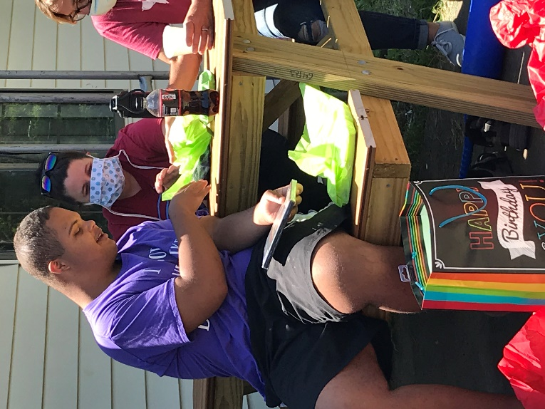

ADMISSION CRITERIA FOR OUTPATIENT

POLICY:
Admission to The Lighthouse, Inc. outpatient therapy program is contingent on the client’s appropriateness for treatment.

ADMISSION CRITERIA
- Person appropriate for treatment
A. In need of outpatient treatment. The Lighthouse outpatient program accepts patients the age of 6 months of age or older
  - Medically stable
  - Able to participate in the program or tolerate the intensive rehabilitation process
  - History of traumatic brain injury (accident, surgical, circulatory), or orthopedic injury or impairment, or neurological impairment, or in need of other rehabilitation services as ordered by a prescribing physician

- Neuro-Behavioral Problems Appropriate for Treatment
  - Cognitive impairment
  - Behavioral difficulties including a limited ability to cope with depression, anxiety, social withdrawal, fears, feelings of hopelessness, severe mood swings, poor impulse control, eating and sleeping problems, lack of motivation, lack of insight and judgment and other adjustment concerns impacting social and vocational development

- Prospective clients are assessed for ability to meet the financial obligation of treatment by either private pay, Health, Auto insurance, workers compensation, Medicare

- For the individual who has sustained a spinal cord injury – The Lighthouse will admit individuals with all levels of spinal cord injuries for treatment

REVIEW PROCEDURE:
- The Outpatient Administrator / Clinical Director will annually review the admission criteria for continued appropriateness
- The Outpatient Administrator / Clinical Director will revise the admission criteria in accordance with the mission and philosophy of The Lighthouse, Inc. program
- The admission criteria will be documented for public disclosure

ADMISSION PROCEDURE FOR OUTPATIENTS
Upon admission to the outpatient program each individual receives a comprehensive assessment evaluation and Plan of Care by each team member initially involved in provision of his/her direct treatment. Patients, caregivers, and primary team members identify treatment goals, discharge plans, planned treatment interventions, treatment intensity, frequency, and duration beginning with assessment phase. Progress and goals are discussed with the patient with each subsequent visit.
Procedure:
1. A script is needed and a verification for approved services is completed by The Lighthouse finance department. Contact is made to the patient informing them of any fees.
2. After approval is provided the patient is scheduled for evaluation.
3. Therapists make recommendations and goals along with determining frequency and completes a plan of care for the referring physician to sign.
4. Goals, frequency, and duration may change depending on the patient’s progress and requirements of funding source. Treatment is discussed with patient and any changes needed will be completed within the plan of care.

AMISSION CRITERIA

Spinal Cord Injury (SCI)

POLICY:
The Lighthouse, Inc. will admit eligible persons with spinal cord injuries of all ages with tetraplegia, paraplegia, and complete or incomplete injuries. Medically stable individuals with co-morbidities, such as a traumatic brain injury, may be admitted to The Lighthouse outpatient program.

PROCEDURE:
- Person appropriate for treatment:
- 6 months of age or older for outpatient program.
- The individual with the spinal cord injury requires the unique services of either a specialized interdisciplinary team or rehabilitation specialists.
- The individual is in need of outpatient services with the potential of functional improvement. Outpatient treatment services provide specialized skills and intensive therapy programs.
- The individual is medically stable; presenting with medical conditions that are manageable in the therapy center, as determined by the referring physician.
- The primary focus of treatment is for physical medicine & rehabilitation, and/or behavioral management.
- The individual does not require continual nursing care, isolation, or medical restraint.
- Persons with SCI are eligible for admission if the level of spinal cord injury and completeness of injury are determined to be appropriate for the level of care provided by The Lighthouse and The Lighthouse treatment team.

- Typical SCI diagnoses include, but are not limited to:
A) Traumatic spinal cord injury
B) High or Low Tetraplegia; complete or incomplete
C) Paraplegia; complete or incomplete
D) Medical conditions/diseases affecting the spine or spinal cord resulting in or producing neurological deficits.

- The etiology of the spinal cord injury or diagnosis will be identified and documented as the information is made available.
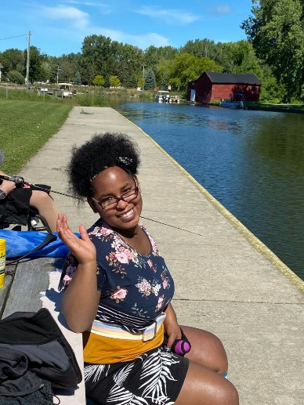
- Prospective outpatients and guardians are encouraged to tour The Lighthouse Inc. facilities prior to admission to the program.

- Prospective outpatients or conservator must show the financial resources and ability to meet the charges either by private pay, insurance, or other financial commitment.

- The Outpatient Administrator / Clinical Director will annually review the admission criteria for continued appropriateness.

- The Outpatient Administrator / Clinical Director will revise the admission criteria as needed and in accordance with the mission and the philosophy of The Lighthouse Inc. program.

- The admission criteria will be documented for public disclosure.

DISCHARGE CRITERIA FOR OUTPATIENTS

POLICY:
It is the policy of the Lighthouse, Inc. that discharge planning is addressed by the treating therapists. The team provides comprehensive evaluation and treatment with the goal of facilitating the clients return to previous levels of functioning.

DISCHARGE CRITERIA:
- Successful discharge:
  - The patient has received maximum benefit from the therapy.
  - The patient has been evaluated by the treatment team and it has been determined that the individual no longer requires treatment services due to the achievement of goals or by consensus of the team that goals will not be achieved in this program.

- Discharge with subsequent transfer:
  - The individual has been evaluated by the treatment team and determined to require more intensive care in a different setting such as a psychiatric hospital or the individual, responsible party, or other stakeholders have determined transfer to a different treatment facility is needed due to patient choice or financial limitations.

- Discharge Against Medical Advice (AMA):
  - A patient or their responsible party wishes to discharge the patient from services against the advice of the treatment team and without adequate discharge planning. The patient and/or the legal guardian acknowledge that they are leaving the program AMA and are aware of the potential adverse consequences.

- Unsuccessful Discharge:
  - The patient experienced a major medical or psychological problem that excludes their benefits from a continued outpatient program.
  - The patient has not successfully attained treatment goals and/or the patient or guardians were noncompliant with agency policies or treatment team recommendations.
  - The patient demonstrates an inability to tolerate the program or modifications, and a different setting is needed.
  - The patient and/or their support system are no longer confident in the program.
  - The overall goal of the person’s program has changed so that outpatient therapy is no longer the best use of the person’s resources.
- The Outpatient Administrator / Clinical Director will annually review the discharge criteria for continued appropriateness.

- Outpatient Administrator / Clinical Director will revise the discharge criteria in accordance with the mission and philosophy of The Lighthouse Inc. program.

- The discharge criteria will be documented for public disclosure.

SUCCESSFUL COMPLETION OF OUTPATIENT TREATMENT SERVICES

POLICY:
All patients that are considered a successful discharge need to complete the procedures listed below.

PROCEDURES:
Successful discharge requires the following:
- Completion of all recommended evaluations
- Regular attendance at all scheduled sessions including individual, as well as family and group sessions, if applicable.
- Satisfactory progress on individual treatment goals.
- Participation in developing a discharge plan including referrals to any necessary social services, treatment, or community resources.
- Determination of medical and/or psychological stability by treatment team.

DISCHARGE NON-VOLUNTARY

POLICY:
The Lighthouse outpatient program shall endeavor to keep all discharges on a voluntary basis. Specific circumstances have been identified that will warrant the termination of outpatient services on an involuntary basis.

PROCEDURE:

- Outpatient personnel will be advised that the following circumstances may lead to involuntary discharge from the program:
  - Third party payor decision to not cover or authorize therapy services
  - Disruptive patient who presents a danger to self, others or property
  - Patient who is actively intoxicated or otherwise impaired by misuse/abuse of pharmacological agents
  - Patient who misses designated therapy appointments 3 times consecutively without calling to reschedule prior to the appointment, e.g. no show
  - Physician’s prescription has expired and a new one has not been able to be obtained
  - Medical conditions which therapists determine contraindicates their ability to participate in the therapy program safely
  - Treating therapists determine contraindication would make therapy unsafe for outpatient

- If any of the instances as defined above occurs, the treating therapist is to report to the Outpatient Administrator / Clinical Director the reason for discharge from services.

- The Outpatient Administrator / Clinical Director will further investigate the circumstances, consult with the management team as needed, and make a determination regarding termination of services within 72 hours of receiving the report from the therapist.

- If the Outpatient Administrator / Clinical Director determines the patient will be terminated from outpatient services, the Outpatient Administrator / Clinical Director or designee shall notify the individual of the need for termination of services.

- Any individual terminated from outpatient services on a non-voluntary basis has the right to appeal this decision to the management team of The Lighthouse Inc. Such an appeal must be filed within 7 days of the involuntary discharge.

DISCHARGE CRITERIA

Spinal Cord Injury (SCI)

POLICY:
Every discharge plan is different and reflects a person’s unique personal and social situation. Recovery from a spinal cord injury often requires people to receive ongoing therapy after discharge. Discharge plans fall into one of four (4) categories:
a) Discharge with a referral for home-based rehabilitation services
b) Discharge with a referral for Day Program services
c) Discharge to another facility
d) Unsuccessful discharge
The Lighthouse interdisciplinary treatment team will address discharge criteria and document discharge recommendations which include each resident’s etiology of injury, level of spinal cord injury, and completeness of spinal cord dysfunction.
PROCEDURE:
- Discharge:
- The outpatient has met the goals established on admission or during the course of rehabilitation.
- The patient has reached his/her maximum potential benefits for outpatient rehabilitation or his/her clinical status has improved. Discharge is appropriate, as the client’s needs may be safely met by another agency or service in the local community.
- Completion of discharge planning may include: providing necessary durable medical equipment and prosthetics; preparing the person served and significant others through education; scheduling follow-up appointments and communicating with other providers for medical, therapeutic, or other required services.
- Documentation completed by the treatment team will include the etiology of the injury, the level of spinal cord injury, and the completeness of spinal cord dysfunction.

- Discharge with subsequent transfer:
- The outpatient experienced a significant medical, surgical, or psychological problem requiring acute medical care or another service.
- Transfer facilitated by appropriate personnel in coordination with the treatment team.

- Discharge against Medical Advice (AMA):
- An outpatient or their responsible party wishes to discharge the resident from services against the advice of the treatment team and without adequate discharge planning.
- The outpatient and/or the legal guardian acknowledge that they are leaving the program AMA and are aware of the potential adverse consequences.

- Unsuccessful discharge:
- Treatment team has reached a group consensus that the outpatient is unwilling or unable to participate in the outpatient program.
- The Lighthouse Inc. reserves the right to discharge individuals who violate organizational policies and procedures or who decline to participate in the agreed upon plan of care.
- The outpatient has not demonstrated evidence of improvement in functional abilities or his/her clinical status.
- The overall personal goal of the outpatient program has changed so that outpatient program is no longer the best use of a person’s resources.

- The resident’s guardian or support system act in a manner, which demonstrates a lack of trust in the treatment program, thus impeding the ability of the resident to benefit from the program.
- The Outpatient Administrator / Clinical Director will annually review the discharge criteria for continued appropriateness.

- The Outpatient Administrator / Clinical Director will revise the discharge criteria in accordance with the mission and philosophy of The Lighthouse Inc. program.

- Individuals who are diagnosed with a spinal cord injury will be assessed for specific discharge needs related to their etiology of injury, level of injury, and completeness of spinal cord dysfunction.

- The discharge criteria will be documented for public disclosure.

DISCHARGE PLAN

POLICY:
Discharge planning is incorporated into the treatment plan from the beginning. Accomplishment of treatment goals, individual patient strengths and weaknesses, family and community resources are all considered in formulating discharge plans and follow-up care. A discharge plan shall be put into effect when it is evident a person will be discontinuing services provided by the outpatient therapy program.

PROCEDURE:

- The professional staff shall write a discharge summary. This summary shall include, but not be limited to, the following:
  - Final diagnosis
  - Patient education
  - Services provided
  - Patient’s deficits
  - Patient’s desired goals
  - Patient goals achieved
  - Reason for discharge
  - Recommendations/Instructions given
  - Precautions
  - Prognosis
  - Therapist signature

- Upon discharge, a Client Satisfaction Survey will be mailed to the patient and/or responsible party.

ADDITIONAL PROGRAMS AND SERVICES

Hippotherapy & Therapeutic Horseback Riding
The rhythmic, repetitive movement of the horse helps improve muscle tone, balance, posture, coordination, strength, flexibility, and cognitive skills in the rider. One of the unique aspects of Hippotherapy is that the horse’s movement share similar to the movements of a human while walking. Therapists address various therapeutic goals by having a patient ride in different positions such as: sitting or lying forwards, backwards or sideways; standing in the stirrups; and riding without holding. In addition, the therapist may have the patient’s stretch, reach, or play games while on the horse.
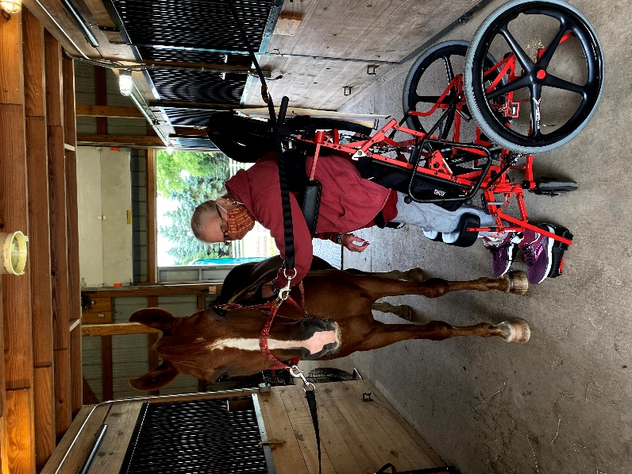
Therapeutic Riding is a supervised riding activity for the purpose of contributing to the cognitive, physical, emotional, and social well-being of people with disabilities. The goals of therapeutic riding are recreation, sport, and overall well-being. Sessions may or may not be not led by a licensed therapist or by a certified therapeutic riding instructor.

Hippotherapy, on the other hand, is a medical treatment provided under a physician’s referral. Hippotherapy is a combination of physical, occupational, and speech-language therapy treatment strategies that utilize the horse’s movements as part of the treatment to achieve functional goals. Hippotherapy literally means “treatment with the help of the horse” from the
Greek word “hippos”. Patients who are successful with Hippotherapy often progress to therapeutic riding.

The Lighthouse offers both Hippotherapy and Therapeutic Horseback Riding for our clients and outpatients. This form of therapy provides a wide scope of treatment for problems including:
- Abnormal muscle tone
- Postural asymmetry
- Impaired balance responses
- Poor postural control
- Impaired coordination
- Decreased mobility
- Impaired communication
- Arousal and attention skills
- Impaired sensorimotor function

Adaptive Sports Program at the Lighthouse
Adaptive sports are traditional sport activities but with the addition of individualized modifications to meet the needs of individuals with physical or cognitive deficits. Adaptive sports programs assist in helping the resident develop confidence and benefit from the added health advantages of increased physical activity and/or involvement in a variety of social activities. Health benefits may include: reduced pain, decreased stress, and improved emotional well-being, as well as a greater sense of independence, and self-confidence.

The Adaptive Sports Program at The Lighthouse is a rapidly growing program that is headed by the Recreational Therapists. Highlights of the program are the Return to Hunting segment and Adaptive Paddling.

In the Return to Hunting segment, Recreational Therapists who are State of Michigan Certified Hunter Safety Instructors, help sportsmen/sportswomen participate in Michigan’s wild-game hunt season. Participants of this program’s segment were hunters before their hunting skills and abilities were restricted by their injuries or medical condition.
The Adaptive Paddling Segment provides The Lighthouse outpatients the opportunity to safely enjoy kayaking activities in local waters. In Kingsley, outpatient can also try adaptive standup paddleboarding too! Kayaking activities are supervised by a Recreational Therapist certified in adaptive kayaking, with training by the American Canoe Association.

The Adaptive Sports Program at the Lighthouse has helped outpatients participate in a variety of athletic opportunities; some examples include cycling, paddling, fishing, hunting, shooting, hiking, yoga, skiing, archery, boccia, equestrian riding, boating, bowling, basketball, rock climbing, and Aquatics.

Orthotics and Prosthetics
Prosthetics and Orthotics is the assessment, production, and custom fitting of artificial limbs and orthopedic braces. The Physical and Occupational Therapists manage comprehensive training and education for the use of orthotics and/or prosthetics using the following plan of care:
Client Assessment
- Perform a comprehensive assessment of the patient
- Obtain an understanding of patient's orthotic/prosthetic needs
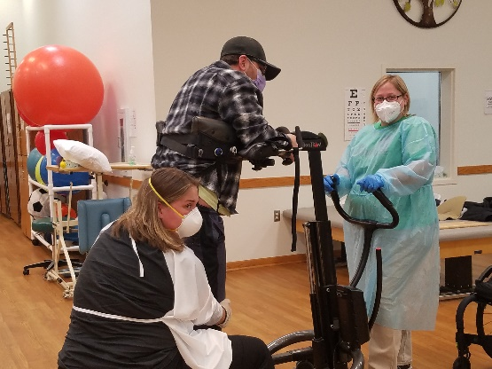
Form/Manage Treatment Plan
- Consults with Orthotist/Prosthetist
- Create a comprehensive orthotic/prosthetic treatment plan to increase stabilization and function
- Diagnostic fitting
- Assessment of intervention
- Functional exercise plan
- Gait training
- Functional training for daily living
- Patient education and instruction

The Lighthouse’s network of providers includes an Orthotist and Prosthetist. Therapists work in collaboration with either the Orthotist or Prosthetist to meet client’s on-going needs.
Pedorthic Service
Pedorthic service is an extension of Orthotics and Prosthetics; where an Orthotist works in conjunction with the Caro Physical and Occupational Therapist to prevent or alleviate foot problems caused by congenital defects or an injury. The Orthotist will design, manufacture, modify, and fit corrective footwear. The Physical and Occupational Therapist will manage new footwear referrals, wearing schedules, and the replacement process.

Vocational Program
The Lighthouse, Inc. provides a full continuum of vocational services to outpatient and day programming clients. These services include a pre-vocational workshop, Level I and Level II (paid, on-site, Enclave services), and community based paid employment. In addition, The Lighthouse facilitates volunteer employment for outpatients who demonstrate an interest in working within a specific realm where paid employment may not be available. The Vocational Program provides educational support for completing applications, writing resumes, and interview skills. The following levels of the Vocational Program assist each client’s needs in exploring individual career opportunities by identifying interests, skills, abilities, limitations, and alternate ways to perform each job task given to them.

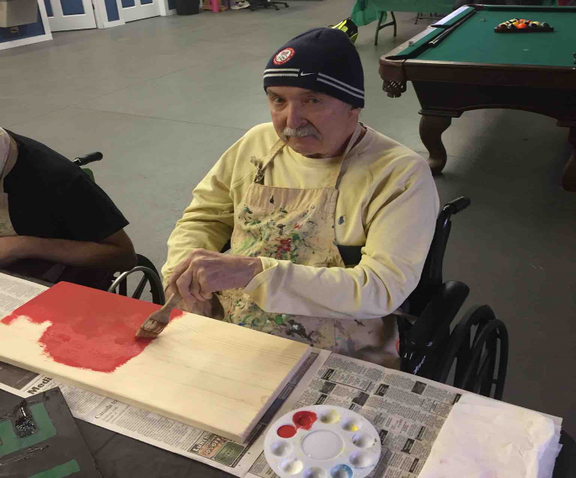
The Lighthouse Pre-Workshop
The Lighthouse has a pre-vocational workshop. This program offers training and the chance to work on skills needed to return to community-based employment.
This level works on:
- Life training skills
- Projects, crafts, and activities to enhance the quality of leisure time and promotes social skills
- Attendance and motivation to complete simple tasks and individual projects

Volunteer and Community Employment

The Lighthouse offers the support clients need to enable them to successfully maintain employment. Some placements are independent with the patient performing their duties under normal supervision. Other jobs require a job coach to be assigned to work with the employee to train, prompt, supervise, and determine alternative methods to complete difficult tasks and duties. At this level support is continued in all areas of the job with the goal for clients to be successful in community-based employment

VitalStim Therapy

Neuromuscular Electrical Stimulation (NMES)
Dysphagia is the medical term used to describe difficulty swallowing. Dysphagia includes difficulty starting a swallow and the sensation of food being stuck in the neck or chest. Dysphagia is common with patients who have suffered a traumatic brain injury, stroke, or normal aging.

Licensed Speech and Language Pathologists are trained to identify and treat dysphagia. A licensed Speech and Language Pathologist who is certified in VitalStim Therapy may administer neuromuscular electrical stimulation (NMES). NMES is the use of electrical stimulation to aid muscle strength and function, activates the nerves, and rehabilitate the process of swallowing.

The Lighthouse employs three NMES Certified Speech and Language Pathologists who are skilled VitalStim practitioners. A typical VitalStim treatment plan begins with an evaluation and an individualized treatment plan that is generally 4-8 weeks in duration.

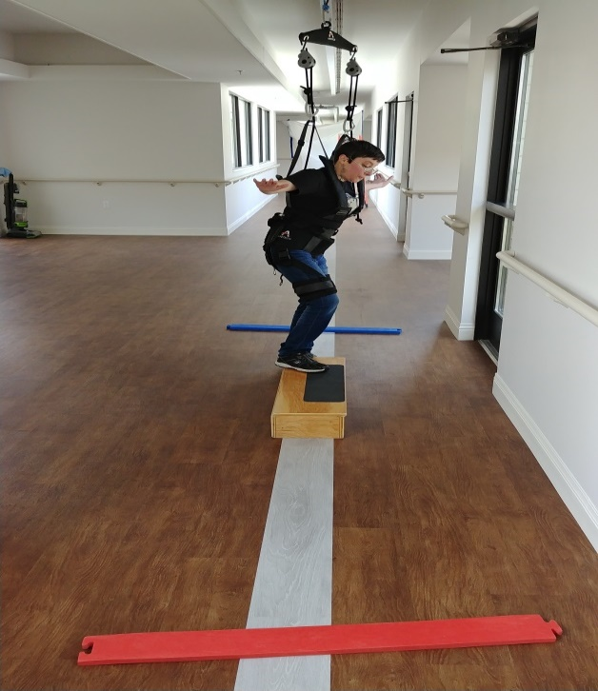
Tai Chi
Tai Chi is a non-impact exercise that works on strengthening the body with minimal stress to the joints. Tai Chi exercises help to improve flexibility, coordination, dynamic balance, postural alignment, body awareness, and neuropsychological functions (memory and attention). Tai Chi also facilitates mindfulness and a state of relaxation.
Tai Chi is a therapy option at the Caro Lighthouse. Both Physical and Occupational Therapists have attended courses are trained in practicing Tai Chi in the clinical setting.

Zero-G
The implementation of the Zero-G into the Physical Therapy practice has provided the Caro Lighthouse Physical Therapists with the opportunity to advance the treatment of patients with many conditions including but not limited to TBI, stroke, orthopedic and balance deficits. This system allows the therapist to unweight the resident and reduce the pressure in the bilateral lower extremities. The technique allows the therapist to provide gait training to outpatients who have significant weight bearing limitations or who present with a severe TBI and/or a Glascow Coma Scale of 10 and below. The Zero-G provides a safe and controlled environment for training/working on the gait cycle, standing tolerance, and balance.

Vision Therapy
The Lighthouse Rehabilitation Center in Kingsley is excited to offer its Vision Therapy Program. Often visual problems resulting from Traumatic Brain Injury are overlooked during initial treatment of the injury. Frequently these problems are hidden and neglected, lengthening and impairing rehabilitation. Vision is the most important source of sensory information. Consisting of a sophisticated complex of subsystems, the visual process involves the flow and processing of information to the brain. Because there is a close relationship between vision and the brain, Traumatic Brain Injury can disrupt the visual process interfering with the flow and processing of information. The result is a vision problem. Symptoms indicating a vision problem are (The Optometric Extension Program, 2013):
- Blurred vision
- Sensitivity to light
- Reading difficulties; words appear to move
- Comprehension difficulty
- Attention and concentration difficulty
- Memory difficulty
- Double vision
- Aching eyes
- Headaches with visual tasks
- Loss of visual field
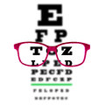
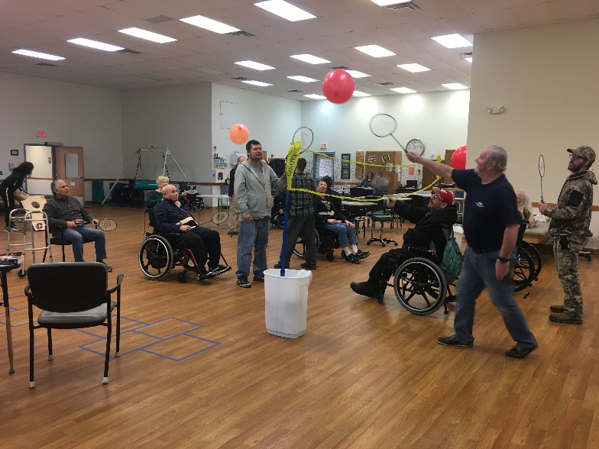
Good visual skills are necessary for efficient information processing. When processing visual information is difficult, one may "try harder," straining without even knowing it because the effort is subconscious. If the visual system is inefficient, every task can seem difficult, using more energy than required. Visual skills affected by Traumatic Brain Injury include but are not limited to tracking, fixation, focus change, depth perception, peripheral vision, binocularity, maintaining attention, visualization, near vision acuity, distance acuity, and vision perception (The Optometric Extension Program, 2013). Vision therapy can develop and/or improve basic visual skills and abilities, as well as the comfort, ease, and efficiency of eyesight, enjoyment of reading and visual thinking as well as many other activities in daily living.

Vision Therapy Modalities:
- Prescription lenses
- Therapeutic lenses
- Prisms
- Optical filters
- Eye patches or occludes
- Electronic targets with timing mechanisms
- Computer software
- Vestibular equipment
- Structured activities that enhance visual perception

Initially an occupational therapist will complete a visual screening. If necessary the patient will be referred to an optometrist for further evaluation. Once seen by the optometrist, the occupational therapist and optometrist will collaborate and treat the visual deficit.

The occupational therapist will work with a multidisciplinary team including physical, speech, recreational, and music therapists in order to address the visual perceptual and visual motor components, including but not limited to balance; vestibular, cognition, and comprehension. The occupational therapist will develop a treatment plan targeting visual deficits and formulate measurable goals in order to achieve functional outcomes. The treatment plan will be evaluated approximately every 12 weeks in order to measure progress and to adjust the treatment plan to meet client’s goals. Clients will typically be seen for 30 to 60 minute sessions 1-3 times per week, with flexibility to meet each client’s specific needs.
Trauma and EMDR Therapy
(Eye Movement Desensitization and Reprocessing)
EMDR therapy is an extensively researched, effective psychotherapy method proven to help people recover from trauma and other distressing life experiences, including PTSD, anxiety, depression, and panic disorders. The Lighthouse psychology department employs a Level 2 EMDR therapist for additional therapeutic services.

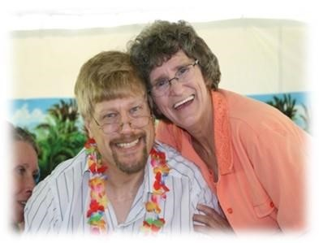
OUR TREATMENT TEAM

Chief Executive Officer
Our Chief Executive Officer has over 30 years of experience with Traumatic Brain Injury, first as mother and the primary caregiver of a behaviorally challenged brain injured son. She oversees the treatment team and is ultimately responsible for ensuring each resident receives proper treatment.

Outpatient Administrator / Clinical Directors
Our Outpatient Administrator / Clinical Directors oversee the clinical therapeutic environment and consult on various professional issues. The Outpatient Administrator / Clinical Directors work in conjunction with other team members on developing and maintaining treatment plans. Outpatient Administrator / Clinical Directors assist Outpatient Administrator / Clinical Director in the decision-making processes of The Lighthouse.
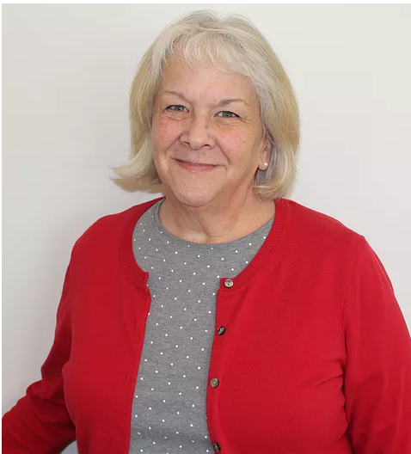
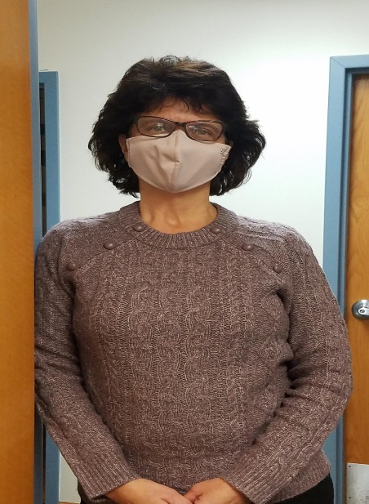

Medical Directors
The Medical Directors provide leadership in establishing a basis for medical treatments for inpatients, outpatients, and day programmers. They oversee each client’s medical regimen, providing guidance in the development of a comprehensive medication utilizing the least amount of medications possible. The Medical Director advocates for individuals with activity and other limitations. They provide psychiatric consultation services and involves persons served, families, and/or significant others in education regarding identified diagnosis and treatment recommendations. They also help the organization’s adherence to the ethical conduct by assisting the nurses, psychologists, and social workers.

Rehabilitation Directors
The Rehabilitation Directors collaborate with the treatment team, and define the composition and duration of the individual’s treatment program. They ensure the plan of service is consistent with individual predicted outcome.

Psychologists
The Psychologists provide individual psychotherapy dealing with such issues as social-emotional adjustment, frustration tolerance, anger management, brain injury education, coping skills, and deficit awareness. They help design and monitor individual behavior programs. Supportive counseling to families as well as consultation to staff is also made available by the Psychologists.
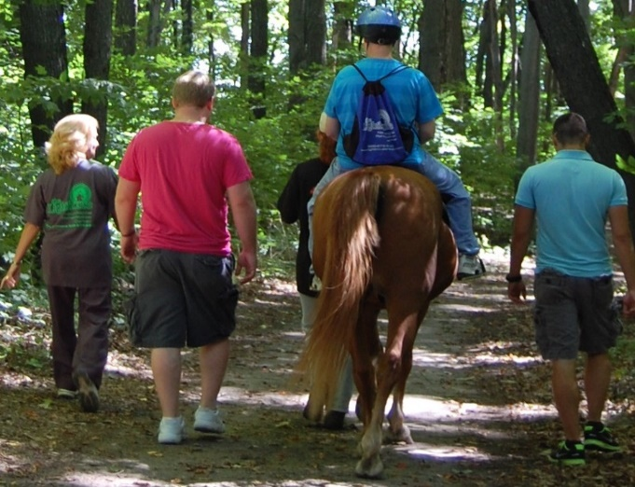

Social Workers
The Social Workers provide supportive therapies, including individual and group, to the patient and family to facilitate social and emotional adjustment. Social Workers provide education on TBI to outpatients and families. They work with the psychologist and therapists to formulate, coordinate, and implement individual plans of services and provide a link that ensures the involvement of family members and/or responsible parties. The Social Worker also provides school liaison services to ensure a comprehensive educational program is established for every child and adolescent.

Registered Nurses
The Registered Nurses are responsible for all administration and supervision of the medical aspects of the Lighthouse program. They provide nursing assessment and care, participate in treatment planning, and work directly with clients. The Nurses provide and coordinate the medical and psychiatric services for the outpatients by consulting with the Outpatient Administrator / Outpatient Administrator / Clinical Director, Outpatient Administrator / Outpatient Administrator / Clinical Director, Medical Director, and the Psychologists. They oversee the administration of daily medications as well as manage the medical services for outpatients by administering and/or supervising special medical procedures as directed by the physician.

Physical Therapists
The Physical Therapists use a variety of evaluative and treatment approaches to help clients achieve the fullest potential possible. Emphasis is placed on function, strength, and quality of movement. Assistive device evaluation is also provided.

Our Physical Therapists evaluate each patient and design a treatment program, which may include the following:

Aquatic Therapy in the Rehab Pool
- Individual Therapy Session

Manual Therapy
- Mobilization of the spinal, extremity, soft tissue, and myofascial release techniques

Exercise Programs
Therapeutic, postural, progressive resistive exercises
- Neuro muscular reeducation
- Stabilization programs

Modalities
- Ultrasound
- Muscle and low voltage stimulation
- High voltage galvanic stimulation
- TENS
- Moist heat/ice pack
- Traction
- Muscle reeducation
- Wheelchair management and training
- Therapeutic massage
- Phonophoresis
- Combo therapy (ultrasound & electrical)
- Paraffin wash bath

Gait Training
- Non-weight bearing
- Partial weight bearing
- Weight bearing as tolerated
Balance Training
- Standing
- Sitting
- Dynamic balance
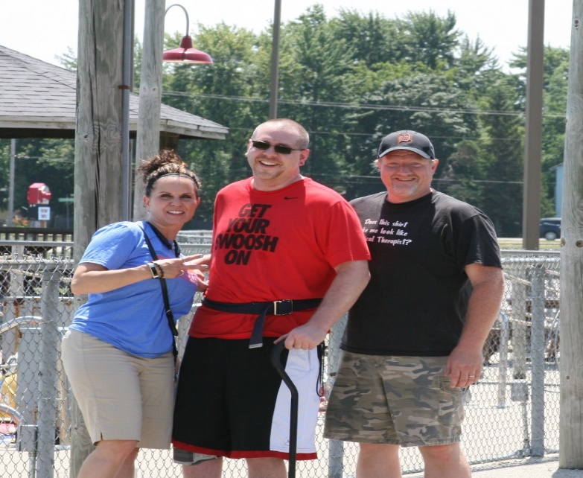

Physical Therapist Assistants
Our Physical Therapist Assistants work closely with the Physical Therapists to assist the clients in increasing independence with movement of extremities. Focus is placed on balance, posture, function, strength, and quality of movement.

Occupational Therapists
Occupational Therapists work closely with clients to increase independence in activities of daily living, including personal hygiene, bathing, dressing, cooking, feeding, and use of adaptive equipment. Skills such as money and time management, work skills and behaviors, problem solving, community safety issues, and memory are also addressed to help the patient obtain maximum potential.

Our Occupational Therapy staff assists individuals to improve their cognitive and physical skills in preparation for independence at home, school, and the workplace. The treatments are individual and may include the following:

Cognitive-Perceptual Retraining
- Visual-perceptual and visual-motor skills such as eye hand coordination
- Visual scanning and localization
- Cognitive skills such as organization & planning, gathering & processing information, functional math and money management, reasoning and problem solving for real life situations.

Activities of Daily Living Skills
- Relearning daily activities such as eating, bathing, dressing, grooming, home management, community living skills, adaptive equipment
- Compensatory strategies for physical and cognitive dysfunction
- Transfer training from chair, bed, tub, shower, and car

Neuro Re-education
- Balance, head, neck, trunk control coordination, range of motion and strengthening for impairments in upper extremity function,
- Endurance
- Cranial-sacral/myofascial release techniques
- Sensory interpretative techniques

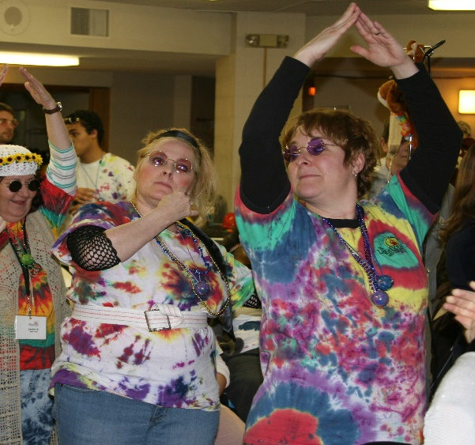

Speech Therapists
Speech Therapists work with outpatients with impaired cognitive and communication skills impaired by brain injury or other disorder. The Speech Therapists help to restore or compensate for lost speech, language, cognitive, and swallow functioning. When oral communication is unattainable, the speech therapist helps the patient learn to use alternative communication methods.
Speech Therapists assist individuals with difficulties in swallowing, speech, thinking, understanding, cognition, and communicating effectively in the following techniques:

Treatment Techniques
• Articulation
• Dysarthria/apraxia
• Voice/fluency
• Oral motor exercises

Language Therapy
• Verbal expression
• Receptive language
• Programming skills

Attention/Augmentative
• Setting up communication device and management

Cognitive Therapy
• Memory
• Problem solving and reasoning
• Executive functioning
• Mental flexibility
• Planning and organization
• Attention to task
• Information processing
• Orientation
• Dysphasia treatment

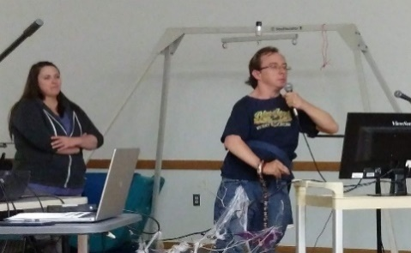
Recreational Therapists
Recreational Therapists strive to meet rehabilitative and leisure needs of all persons limited in opportunities by training and equipping the patient to achieve his/her optimum level of abilities. They provide opportunities for success by engaging in activities of creative self-expression, social development, self-awareness, and learning intellectual development essential to the rehabilitation process and community reintegration.

Massage Therapist
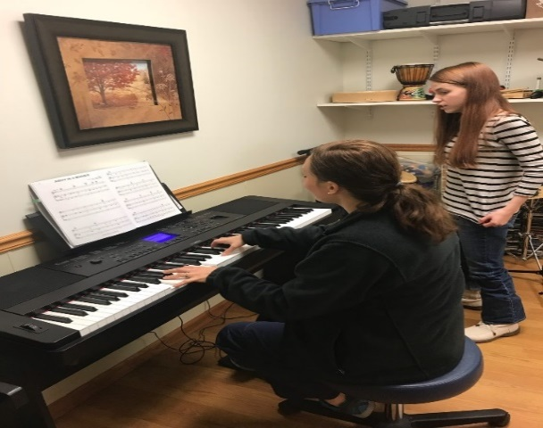
A Massage Therapist is someone who is trained and skilled in massage therapy for medicinal benefits. Massage therapy is the manipulation of the soft-tissue and muscles of the body and it is used for many different reasons. Among the reasons for massage therapy is to relax overworked and tired muscles; to treat pain that results from any number of ailments; to aid in the rehabilitation of athletic injuries; and to support overall good health.

Music Therapists
Music is an ideal therapeutic tool because of the special place it holds in our day-to-day lives. We use many forms of musical experience (listening, playing instruments, singing, moving to music, creating and discussing music to relax or energize) to teach, to express feeling, to stimulate memories and to bring us closer to one another. The Music Therapists are trained to structure all these aspects of music experience to improve communication and to promote social, emotional, motor, and cognitive development.

Vocational/Workshop Directors
Vocational and Workshop Directors are specially trained in vocational development, supportive employment, job coaching, and time management studies. The Lighthouse has a vocational program that addresses vocational development, supportive employment, job coaching, and time management studies.
Clients are individually evaluated for strengths, weaknesses, and abilities as related to employment potential. The Vocational and Workshop Directors participate in interdisciplinary team with insights into the functional areas of the clients.
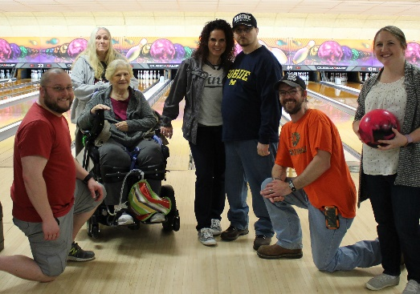

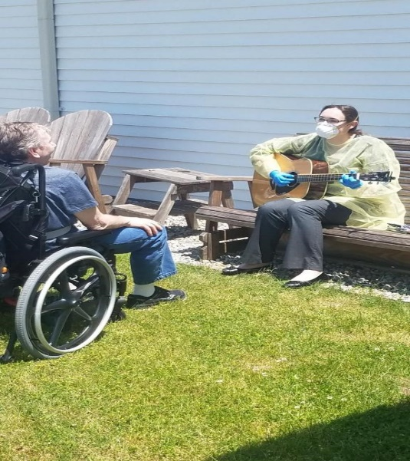
Program Directors

Program Directors facilitate communication across the continuum of care and are instrumental in planning and training services.

Rehabilitation Aides
The Rehabilitation aides provide quality personal care, implement behavior plans, structure activities, attend medical appointments, assist in the completion of therapeutic actives, and provide ongoing supervision and support. Based on the client’s medical acuity the Rehabilitation Aids who receive additional training provide extra care for trachea, IV antibiotics, bowel and bladder training, and ensure patients follow dietary and dysphasia guidelines.

Home Managers
The Home Managers work with the interdisciplinary team to effectively manage the outpatient homes to oversee all resident care needs. They ensure the provision of quality personal care, implement behavior plans, oversee activity schedules, attend medical appointments, manage medication administration, assist in the completion of therapeutic activities, and provide ongoing supervision and support to motivate staff to do their best. Home Managers effectively oversee the day-to-day operation of the home on a variety of different ways including in keeping the homes clean and orderly as well as coordinating the transportation needs of the outpatients.

Medication Technicians
The Medication Technicians work with the interdisciplinary team to effectively administer medications appropriately and accurately. Medication Technicians assist the Home Managers in the day to day operations of the home. They provide quality personal care, implement behavior plans, structure activities, attend medical appointments, assist in the completion of therapeutic actives, and provide ongoing supervision and support. Medical Technicians follow all doctor orders pertaining to medication needs for outpatients. They oversee all relevant documentation of medication distribution to each patient. Based on the patient’s medical need the Medication Technicians will receive additional training to provide extra care for trachea, IV antibiotics, bowel and bladder training, as well as dietary and dysphasia guidelines.

Rehab Specialists
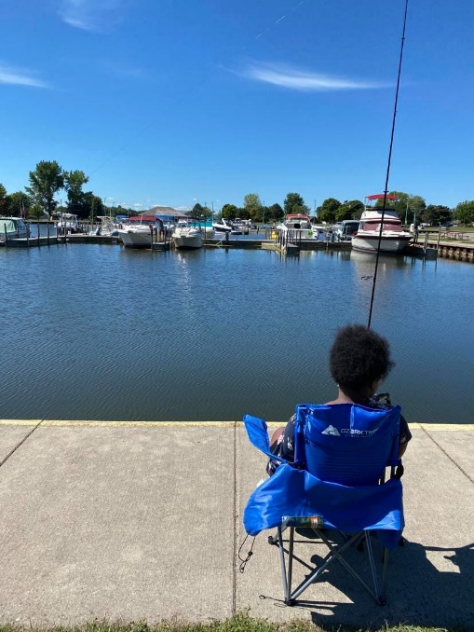
Our Rehab Specialists provide leadership in coordinating the complex rehabilitation services of inpatients, outpatients and day programmers. They are responsible for the assessment of rehabilitation needs for identified outpatients and present findings in a manner understandable to the person served for prognosis and discharge. They work in collaboration with the treatment team in defining the duration of the individual’s treatment program to help ensure the plan of service is consistent with the individual’s predicted outcomes. The Rehab Specialists also provide medical care directly or through arrangements with other physicians. This includes care for continuing, unstable or complex medical conditions.

Community-based Services
Community-based services aid our aging community and individuals with physical and cognitive deficits to maintain independence to the fullest extent possible. Maintaining one’s independence may mean remaining in the comfort of one’s own home or residing in a semi-independent living arrangement.
Community-based services may be provided by a number of service providers.

Region VII Area Agency on Aging: Partner with local organizations to provide
- Access services
- Community services
- In-home services
Thumbody: Public transportation providing service to
- Caro
- Indianfields Township
- Almer Township
Fresenius Medical Care: Offers dialysis treatment and support for individuals living with chronic kidney disease and ESRD.
- Caro
- Limited service to Cass City, Mayville, and Vassar

